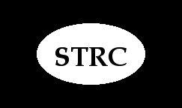 Update: June 2026

Hi all, this will be short, but I hope some helpful advice and reminders. I want to strongly remind you of the importance of the back in centering the head and the recovery process. As all of you know, Torticollis tends to twist, not only the head and neck but the back as well and what is happening in your back is highly related to what is happening in your head and neck. This is why some important back exercises are included in your program, such as the Bend-Hang, the cross- legged-body- curl, the straight chair
stretch, pole twist, and a few others that you feel in your back, along with of course, the rowing machine. If you are stooped over and your back is tight, and you try to lift and straighten your head, it will be very difficult, because you need the help of your back to do that. This is why doing the Drop and Roll…. back against a wall, will so often still the tremors and enable you to center your head a little bit, even if only for a few seconds. So, this is why it’s so important to daily work on your posture and try to stand and walk erect as possible. If and when you do that, you will find it is easier to center your head a little bit, but as you know, this is a process and happens day by day. Some people find that it’s easier to center their head when they are lying down on their back, and that is because the back is then somewhat erect and straight. So, begin to remember this, as you are going throughout your day, walking, exercising, sitting, etc. When you are thinking to yourself that you need to lift and center your head, first be thinking that you want to make your back more erect at the same time – and then try to center and left your head. As you try this over the next few weeks, email me and let me know if this is helpful to you.

Next, as you know, massage for a few minutes daily is vital to the recovery process, but here I want to specifically focus on massage across the top of the shoulder and side of the neck when the head tilts way over to one side, as seen in this photo
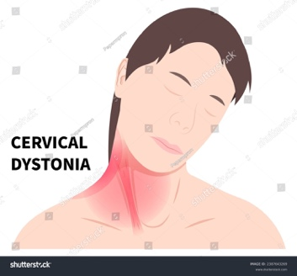
Clearly, in this photo, her left side is the short side, and although we work both sides, that left side needs a lot more elongation using the exercises, but here I want to address the use of massage in this area. The person doing the massage with their hand slightly oiled would run the heel of the hand across his left shoulder and up the side of his left neck, stretching as he goes. The person doing the massage could place one hand along the top of the head and pull the head slightly toward the center, and then with the other hand do what I just described above. This should not hurt, and it needs to be initiated very slowly, so as not to shock the muscles in that area. The person doing the massage can also stand behind you as you sit in a chair with your head, leaned a bit forward and do what I call the skull rock. You will find this on our free massage demo on our related links page https://stclinic.com/related-links/ (the skull rock is at the 17:30 minute mark)
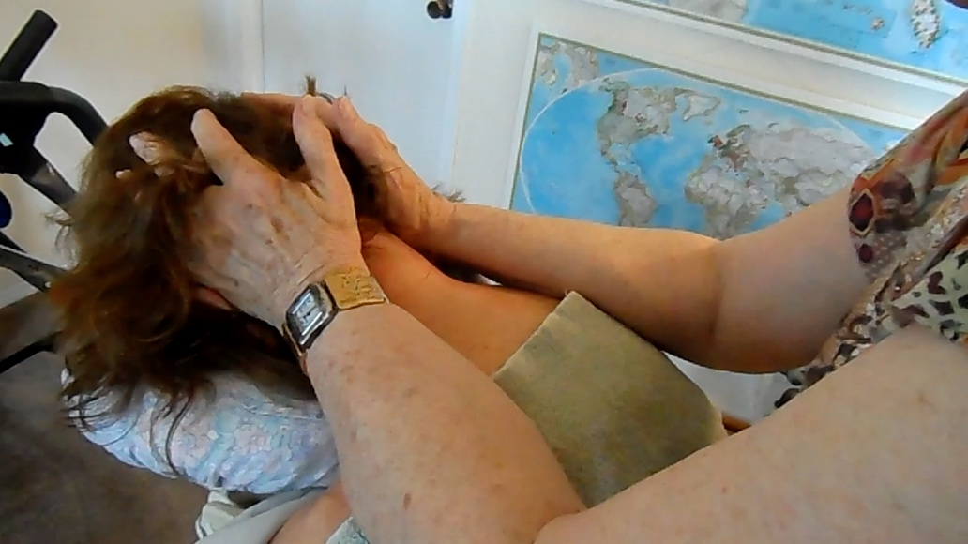
but here is a MP4 movie that I hope will come through in this email showing you how to do this from the back.

Double click on it to start the very short demo film. Just remember that gentle elongation is the key to getting rid of the spasms!
God bless all of you. Love, Abbie

************
S.T.R.C.,Inc..
Abbie Brown, Director
P.O. Box 86
Ranchos De Taos, NM 87557
To unsubscribe, reply to this email with UNSUBSCRIBE in the subject line and body of the email.

