Spasmodic Torticollis Recovery Clinic, Inc.
S.T.R.C., Inc. P.O. Box 86 Ranchos de Taos, NM 87557 575-737-1144 Abigail Brown, Director www.stclinic.com stclinic.info@gmail.com

Hi all, I hope all of you are working the program and not snowed in. I’ve included a few reminders here. but I wanted to talk about cold packs first. Cold is by far best for the neck and head if using a wrap for a period of time, although hot baths, Jacuzzis and warm pools are wonderful for the entire body. You already know about the Elasto-Gel Cervical Neck Wrap pictured in your Guidebook and available on Amazon. That’s nice for the neck and shoulders, but you might have pain in other areas. A few updates ago I mentioned the 5 inch Pain Cakes (do a search online) These are now a little hard to find, but Amazon has pretty much the same thing. Do an Amazon search for Reusable round cold packs and you will find many examples. These can go anywhere on your body . Cold can reduce both pain and spasm. You know S.T. begins in the head in the basil ganglia, so those muscles in the skull are always short in a person ST whether you feel the shortness or not. The tool to elongate those skull muscles is the military! If you do a military back against a wall, neck pressed toward the wall and chin tucked, you should feel a real strain as the muscles in the back of the skull as they lengthen. If, when doing an exercise, you do not feel that same se3nsationkl you are not doing the military correctly, so practice against the wall to teach your body the correct position for that. Many ST’rs will feel a pain or pinch up the side of the head on the short side between the ear and the center of the head. This can happen anytime, sitting, lying down, etc. For that you can place a pain cake still in it’s wrap on the back of the head for some relief. Then not long ago I got a brain storm; so many need to brace the short side while lying down, so the head does not pull of drift off center toward the short side. You can use the U-shaped pillow for this or some extra pillow but here is what I found is great for the base or side of head or back of head, and you can make this at home for pennies. It ends up being a cold tube about 8 inches long and 3 inches wide3, like a summer sausage. I made one and love it. It braces the side of the head and the cold is so soothing. It’s still a light brace when thawed but a stronger brace while still frozen. So here is how you make it and a photo and a video of a woman making one.

OR you can make a Sand or dirt pack: place 1 and ½ c. sand or dirt in a quart size baggie; push out air and zip closed. Fold into a tube. Place in a tube sock and freeze. This creates a pretty solid cold brace for the side of the head.

But I like the gel pack, so here is the recipe:
Home made gel pack
3 c. water
½ c. salt
¾ cc.. cornstarch
2 quart size zip lock bsggies
1 roll packing tape
Put cornstarch in small bowl and add few tablespoons cold water and wisk to dissolve. Set aside.
Boil the water. Add slat and stir to dissolve. Add cornstarch and stir to completely mix. (if you don’t first dissolve in cold wter, it will be lumpy when you add it to the water and hard to dissolve) Bring to a boil again and stir until it thickens into a goo. You can add a few drops of food coloring if you wish. Cool completely. Fill baggie with all but about 2 tablespoons of goo and throw that bit of leftover awy. Push out air and fold into a tube. Put 2 or 3 strips of packing tape around the tube. Then place that in another baggie. Fold so it makes a tube shape. Tape around that again and place in a tube sock and freeze. This will stay cold for a long time and remains flexible but very firm while frozen.. Video Demo:
https://www.youtube.com/watch?v=3k210f6aTAU
Here is a photo of the one I made.
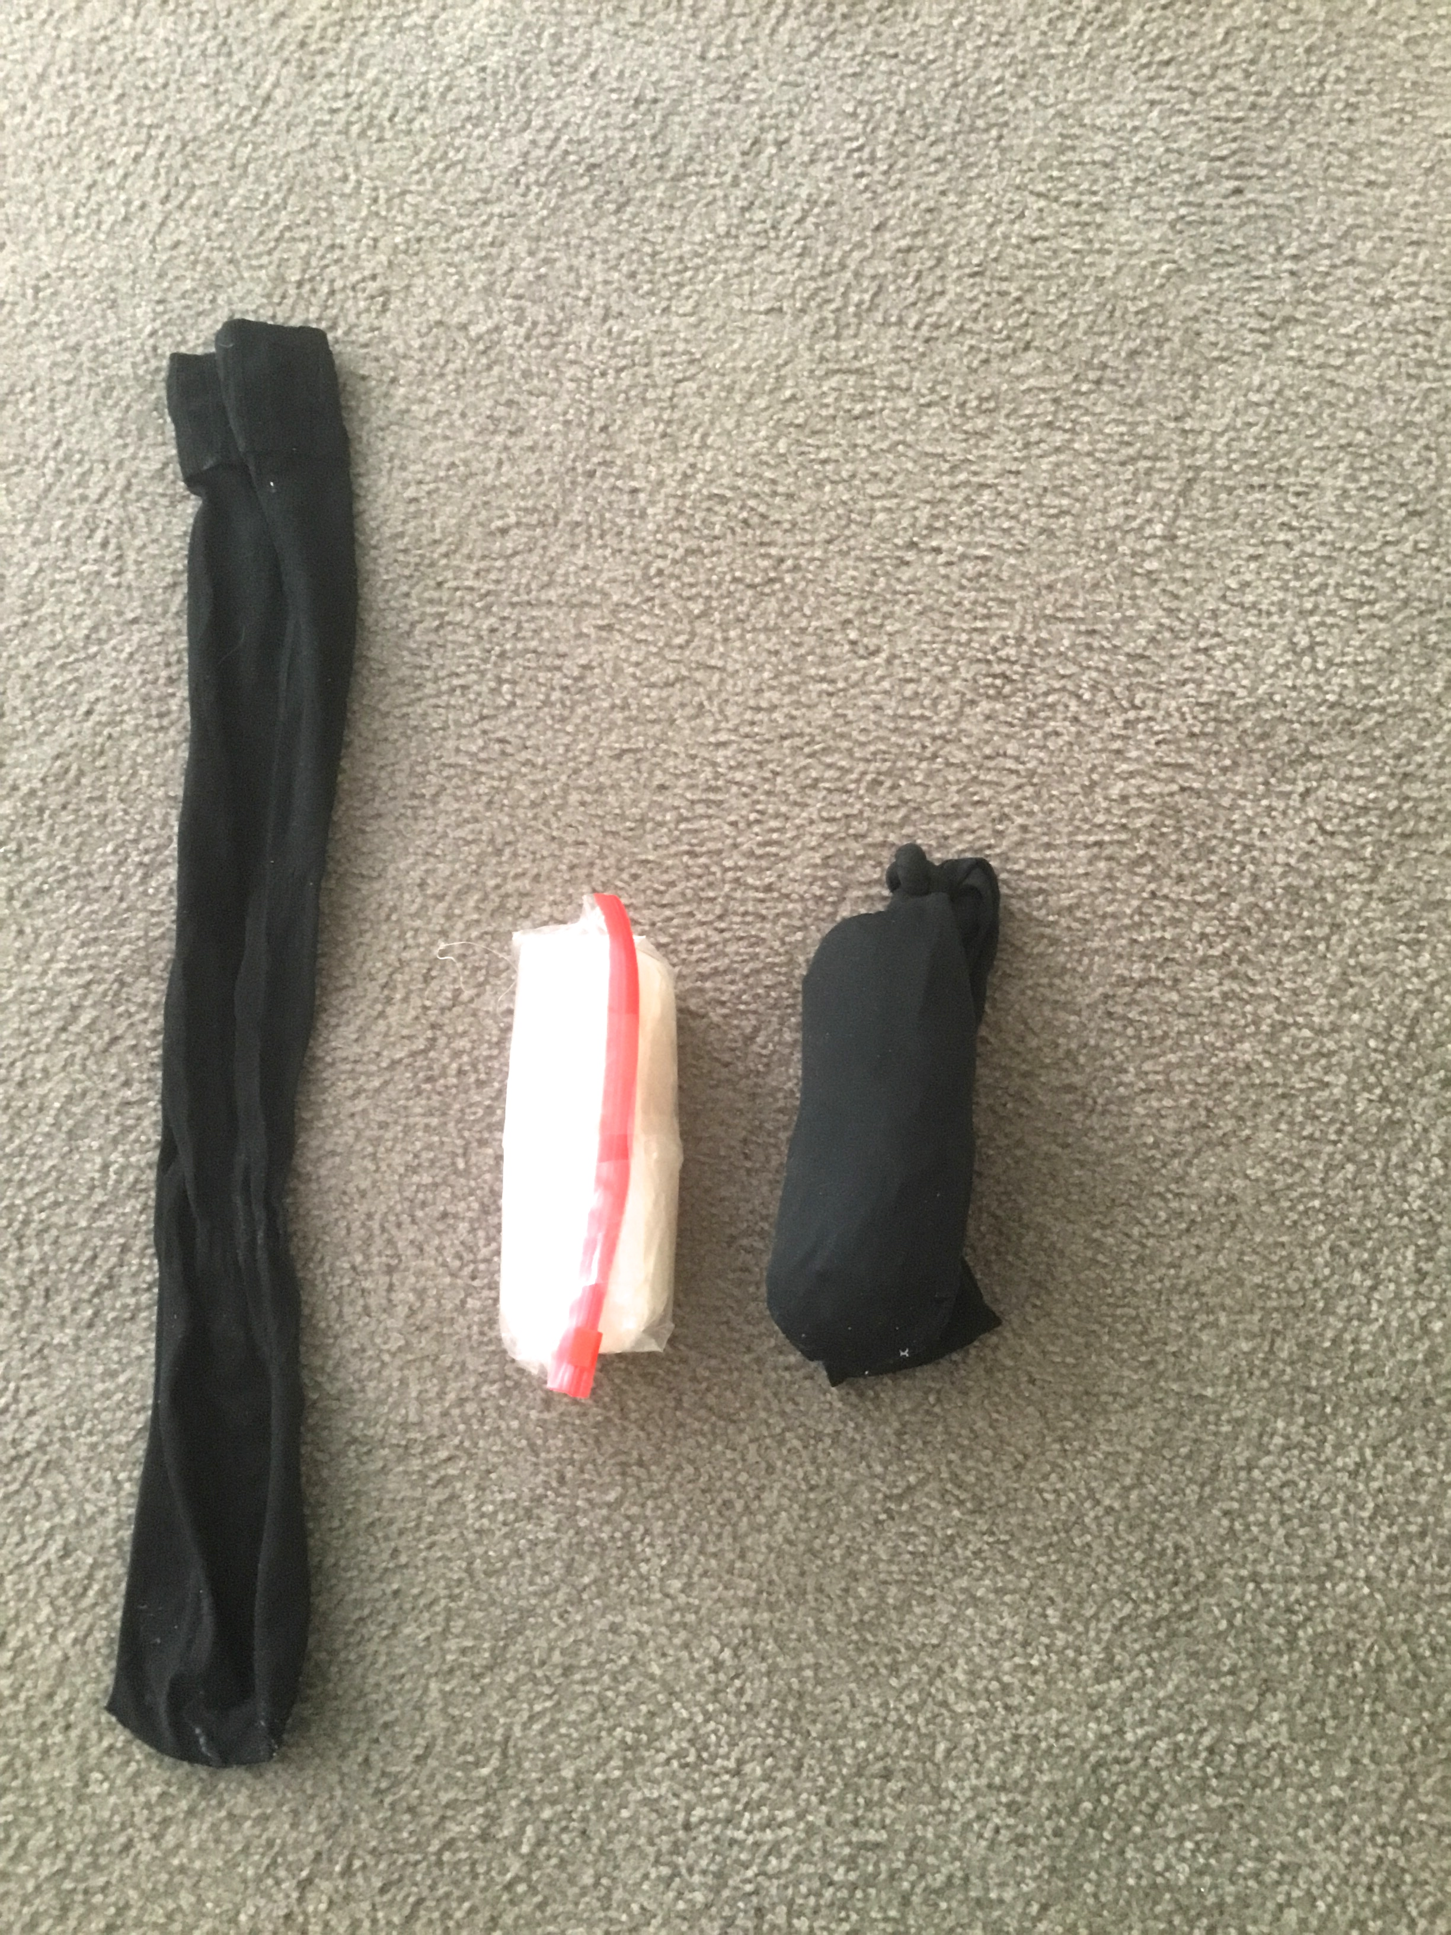
A reminder that our new massage demo video is up on our Related Liniks page.
http://stclinic.com/related-links/
Remember that patience and persistence are key and your body will reward you! God bless all of you. Abbie

