Spasmodic Torticollis Recovery Clinic, Inc.
S.T.R.C., Inc. P.O. Box 86 Ranchos de Taos, NM 87557 575-737-1144 Abigail Brown, Director www.stclinic.com stclinic.info@gmail.com

Hi all, I hope some of the following tid-bits will be helpful. Try and stay cool in these hot summer months. If you don’t have A/C, I‘ve seen several portable units online. Heat and humidity tend to be hard on the muscles. I mentioned these little Pain Cakes before, but this is just a reminder. Remember, cold for the neck and heat for the back. Many of you have the Elasto-gel cervical neck wrap and those are great. These pain cakes are more targeted to vrious parts of thje body.
Pain Cakes; I’ve mentioned these before but just a reminder. These are used as stickies but if left in package, can be placed on the back of the head (hair) while lying down. You would want to order the large, not the mini The large are 5 inches in diameter. The only place I’ve found them is on ebay.om.

Exercise #1 part 1: put hands on knees fingers pointing together, rather than forearms as shown in the Guidebook. Both work but you get a better stretch in the back with hands on your knees. Remember the very important exerises specifically designed to center the head and elongate those muscles: he Head Raise and Chin Smile, Foot Strap (called a yoga strap on amazon.com), Cross-Legged-Body-Curl, and Head Harness. On any exercise when you are hanging over or down, breathe (exhale) to further elongate thoee back and neck muscles.

NEW archived Update link: For years I’ve used wix.com site for our old updates, but recently have not been able to login, even using facebook or google and they won’t respond to my emails, so I’m done with wix.com!!! I’d suggest you no5 use ttha site for anything. So I’ve added a new archived update page linked to our site. This is ONLY for clients. Please do not put thi link on the web or give it to anyone unless they are a former STRC client. Thanks. Here is the new page - for your eyes only:
https://stclinic.com/updates

New gizmo: over a year ago I ordered a new tool similar to the Occipivot but thought it was a little weird so never used it and stuck it on a shelf. A week ago I found it and began using it and really like it. You do NOT have to get this to achieve recovery but for those of you who like additional gadgets, you might like this. Depending on how you turn it, you can do trigger points on the back of the head and also trigger points down your back ( if sitting fairly straight in a chair). Remember that people with ST have shortened muscles in the back of the skull so scrubbing the back of the head with knuckles and trigger point there is helpful, but it’s the military that elongates those muscles. It’s called a Cervical Traction Occipital Release Tool - Here is a photo. If you do a search on amazon.com for the Occipivot and scroll down that page, you. Should find this tool.

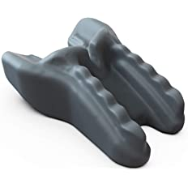

Recliners: Many have asked bout recliners. Generally I don’t’ recommend them, because they are not zero gravity, (where your legs and feet are up as you lean back.) If you can find one like that, it should be fine. When leaned back, it almost becomes like a zero-gravity adjustable bed, and those are just wonderful for anyone. I have one. A zero-gravity recliner does not have to be as extreme as seen in this image, but you get the idea. Here is a photo of a zero-gravity recliner:

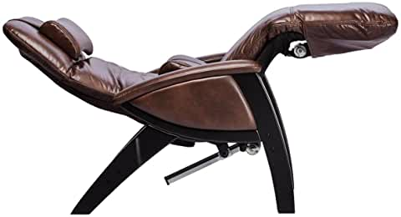

NEW BOOK”: I jjust received a gift copy of a wonderful looking book sritten by a client’s husband, Stephen Berberich. You can find it on amazon.com Here is a link:
https://www.amazon.com/Travis-Hunter-homeless-mysterious-post-traumatic/dp/B097BW526T/ref=sr_1_1?dchild=1&keywords=stephen+michael+berberich+travis+hunter&qid=1625747995&sr=8-1

And a bljurb. Travis Hunter: War hero found homeless in mysterious post-traumatic state Paperback – June 21, 2021

Wounded war hero Sgt. Travis Hunter has a debilitating post-traumatic condition. He doesn’t know what it is. It is a neuro-muscular condition, which has frozen some of his head and neck muscles to one side. The mysterious medical condition hit him several months after his Army discharge. The Veteran's Administration doesn't recognize it as combat related.

It’s a story full of inspiration and hope for a man with Dystonia; Sadly I can’t read it due to my vision loss but am trusting god for a miracle and restored vision. Thanks for your prayers!

A NEW recipe: it’s been a long time since I shared a recipe but this one is so outrageous that I have to pass it along. You can occasionally treat yourself to a bit of chocolate or a desert (don’t be a martyr) as I did the entire time I was recovering; you just don’t’ want to over-do the sweets. Just a bit now and then as a treat is fine, unless you have some issue like diabetes. I found this online just browsing for a frosting recipe but forgot to bookmark the page. It had dozens of 5 star OMG type reviews, so I tried it and will never make another frosting - ever. So simple and frosts a 9 X 13 inch pan. Only 3 ingredients:

Freeze a stainless steel bowl for an hour and bake the cake of your choice. Cool cake to room temperature. Put 1 pint of heavy whipping cream into bowl and whip to right before soft peaks begin to form. Then add 1/3 cup powdered sugar (I add a couple of extra tablespoons) and whip to right before you get stiff peaks. (if too stiff, your frosting can turn to butter) Then add one small (about 3 oz.) package instant white chocolate pudding mix powder. Lower to lowest beating speed and beat into cream. It will set up very fast and thicken. The frosted cake can sit out at room temp for hours or overnight and the frosting remains perfect. I tried it also using a chocolate pudding mix. To the powder I added 2 teaspoons Hersheys cocoa powder. Then added to the whipped cream and it turned out great. Enjoy!!

God bless all of you, Abbie

