Hi all, First of all, thank you from the bottom of my heart for those who have sent donations!!!

The Shitsu Massager Unfortunately the cordless and rechargeable type is no longer available. It’s availability seems to come and go. This one is exactly the same but not rechargeable. It’s just like mine and I love it. It works just as well as the old Kneading Fingers for way less money. You can paste this into your browser search bar or go to amazon.com and do a search for Zyllion shiatsu neck and back massager
https://smile.amazon.com/Naipo-Shiatsu-Massager-Kneading-Shoulders/dp/B07GDGHJGC/ref=sr_1_26?dchild=1&keywords=shiatsu+deep+Tissue+massage&qid=1604790012&sr=8-26Guidebook translate into

As you scroll down the page you’ll find others like it , some in different colors and some variation in price.

Our Guidebook now in Spanish via the Chile Dystonia Foundation. With our permission the Guidebook is being translated into Spanis.We do not receive any money for this, but it’s great to know the course will be reaching those I could never reach. They won’t have the DVDs or ongoing counseling but at least they will have the Guidebook, which has enough information for them to get into recovery mode.

Difficult Days: Things have been very difficult for the clinic financially. We have had only two In-House clients since Covid began and only a few Long Distance clients; that has left us with a serious shortfall each month. I’ve set up a page on a new site: GiveSendGo which is similar to GoFundMe but I like it better. Here is our page, and I deeply appreciate the help at this time:
https://givesendgo.com/GWRX
The only place we advertise is on the search engines, primarily Google and Yahoo. I pay $195.00 per month to a Google broker to be on page one but, due to algorythms or some such thing which I don’t really understand, we often end up on page 2 or beyond. I’d be so deep be grateful if any of you who visit ST forums or bulletin boards would mention the clinic and point the people there to the clinic: https://stclinic.com/ Thanks so much!!!

For some, the U-shaped pillow and Occipivot can instantly stabilize your head in bed or lying back on the floor. For others not, but it’s worth a try.

Practice posture: do the military/Eeee back against a wall. Then, holding that position, walk a few steps away from the wall. Keep practicing until you can increase the number of steps with your head centered in a military/Eee. This will build muscle memory for normal. Be patient - one step at a time. If this week you can take 2 steps and next week, 3 - that’s HUGE.

For those of you who are new clients, remember that we have a page with archived old updates.(this page is for clients ONKY! Please don’t share this link. )
https://abbiec5.wixsite.com/updates

Addressing Frustrations: I fully understand the frustration of those who still struggle with shortness on the neck muscles, as I went through it. Remember some key issues: elongation is the goal
1. The muscles in the skull on your short side are also too short. The military gets into those along with the chin--smile and Head Harness and a few others. Also scrub the back of your skull with your knuckles and practice the
Drop & Roll off and on during the day. The Eeee realigns the jaw, thus freeing up the Trigeminal nerve, which apparently stops the mis-firing of the cranial nerves and helps to normalize the level of both acetylcholine and Adrenalin back to normal and this is central to getting rid of the symptoms of ST.
2. the muscles in the back of the neck and down the upper back need massage daily, and exercises like the head raise, chin smile, foot strap, cross-legged-body-
curl and head harness. Remember to work your back; the neck will not want to release if your back is tight.
3. For the muscles along the top of the shoulder, especially on the short side, use the
Accu-Ball masssage tool
Accu-Ball Demo: https://www.youtube.com/watch?v=vp5HpaHZsRE
To buy: https://smile.amazon.com/Relaxus-Accu-Ball-Kneading-Massager/dp/B0050C8ZO6/ref=sr_1_5_a_it?ie=UTF8&qid=1547151584&sr=8-5&keywords=accu-ball+massage+tool
and the
Shepherd’s Crook or
Back Buddy punching down into the top of the shoulders. Also do shrugs for this area.
Do these above exercises DAILY. Even the Head Harness can be done daily, beginning with light weight and gently working up to more weight as your body can tolerate it, and you can use your
Bodylastics for this.

1-900 Miracle Book: I have recently finished an edit of my 1-900 Miracle book: it’s available in hardcopy ordering from me at the clinic and using PayPal or personal check. (Total cost including postage for U.S. clients only is $20.00) Here it is on amazon kindle for those over seas or those who prefer kindle reading.
https://smile.amazon.com/1-900-Miracle-odyssey-amazing-broken-ebook/dp/B01NH9LIZ7/ref=sr_1_1?dchild=1&keywords=1-900+miracle&qid=1599089493&s=books&sr=1-1#reader_B01NH9LIZ7
I hope that this will be a source of encouragement and hope for those of you who need it during these times. There is a chapter on my own struggle with ST and another chapter on the genesis of the clinic. You can read the first 2 chapters for free on kindle at the link above.
An update on my eyes. Thank you So much for praying for me!!! A this point it’s in God’s good hands. I can barely drive and no highway or night time driving. I recently found a product and have ordered a 7 month supply. Many people are regaining their sight from macular degeneration using this. If you or if you have friends or relatives with MD, maybe you could send them this lonk. It’s about an hour long but fascinating info.
https://thetruthaboutvision.com/vc/researchNR195ZF/?subid=sfn

Last of all, I have an adorable new Grand-puppy. My son and his family adopted a St. Bernard puppy named Simon. Here he is with my
Grandkids.

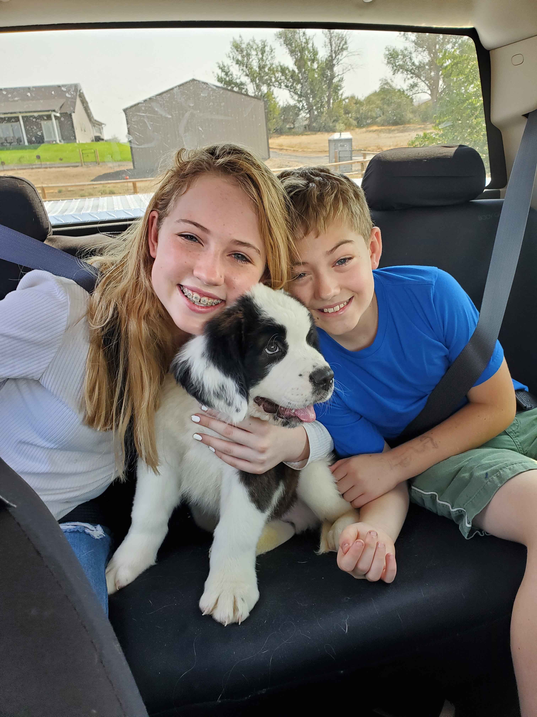

God bless all of you as we head into winter. Love, Abbie

