Hi all,

First of all, I want to DEEPLY thank those of you who have given donations to the clinic recently. We’ve had no clients since the Covid-19 crises began so your donation is needed as never before - again, a big thank you!!!!

Regarding your shoulders:
Most ST’rs have one shoulder that is tighter than the other - almost always, that’s on your short side. The massage machine
https://smile.amazon.com/TENKER-Cordless-Shiatsu-Shoulder-Massager/dp/B07TF8LX6Q/ref=sr_1_4?dchild=1&keywords=Cordless+Shiatsu+Neck+Shoulder+Back+Massager&qid=1586538349&s=hpc&sr=1-4
does not address the shoulders (I see today it’s unavailable but that availability comes and goes as it’s a popular item ) but there are two products that do:
The Shepherd’s Crook and the
The Accu-ball massager. See a video demo here: https://www.youtube.com/watch?v=vp5HpaHZsRE

If someone is doing massage for you,, have that person watch again our free massage demo on our related links page. https://stclinic.com/related-links/ You will see Myra pushing down with the heel of her hand down the side of the neck and across the shoulder to elongate those short muscles along the top of the shoulder, especially on the short side. If you turn one way and lean the other, that is an induction that both sides are fairly even in terms of shortness and involvement; in that case you want to work to elongate both sides fairly evenly. The exercises that are most helpful are the Straight Chair Stretch, especially part 2. In part one you are stretching the lower back as you are bending down and then as you roll up into a strong military/Eeee,, the stretch/elongation moves to the back of the head, neck and upper back. In part 2 you are getting a huge elongation along the top of the shoulders as you lean from side to side Be sure to let your head drop down as much as you can Remember you can use a big exhale to let your head to drop and release. As you exhale, let your head drop down. This takes practice, but it will happen. Then the second part of the Over-Hold is also helpful in the same way. Then of course sleeping on your back is so important. You can do this. It took me months to teach my body to back sleep but now I have my body so trained that I can’t fall asleep unless I’m on my back. Just keep practicing, one night at a time. I still use the Occipivot every night, just because it relaxes me and helps me to sleep. No more than 20 minutes for that. You can watch the video demo here: OCCIPIVOT DEMO: https://www.youtube.com/watch?v=Jay0Z88rS1g
WE ST’RS NEED TO PUT THE OCCIPIVOT ON A PILLOW WHEN USING IT SO THAT YOUR CHIN IS SLIGHTLY TUCKED.
As most of you know, I also recommend a heated mattress pad which will help you to avoid rolling over to one side curled up to stay warm in bed. I like the Beautyrest one.

I hope some of this will be helpful. If the top of your should is tight, your head will not be able to center, so getting those shoulder muscles elongated and softened is vital. Remember also that if your back muscles are tight, the neck will not want to release, so do your back exercises - like the Bend-Hang, Seated Pull, Head raise, and rowing machine.

Avoiding Toxins: Clearly we want to avoid all the toxins we can - in air, food and water, etc. Remember that Carbon Monoxide is on no-no list - so, I advise putting the air in your car on recycle, not fresh intake.

PLEASE NOTE !!! WE HAVE A
NEW POSTAL ADDRESS:
S.T.R.C., Inc.
P.O. Box 86
Ranchos de Taos, NM 87557

A client sent me this link for that you can use in bed for an iPad or laptop. I’ve not tried it but it looks like something that might be helpful. https://www.walmart.com/ip/Pillow-Pad-Multi-Angle-Cushioned-Tablet-and-iPad-Stand-Burgundy-As-Seen-on-TV/835109419

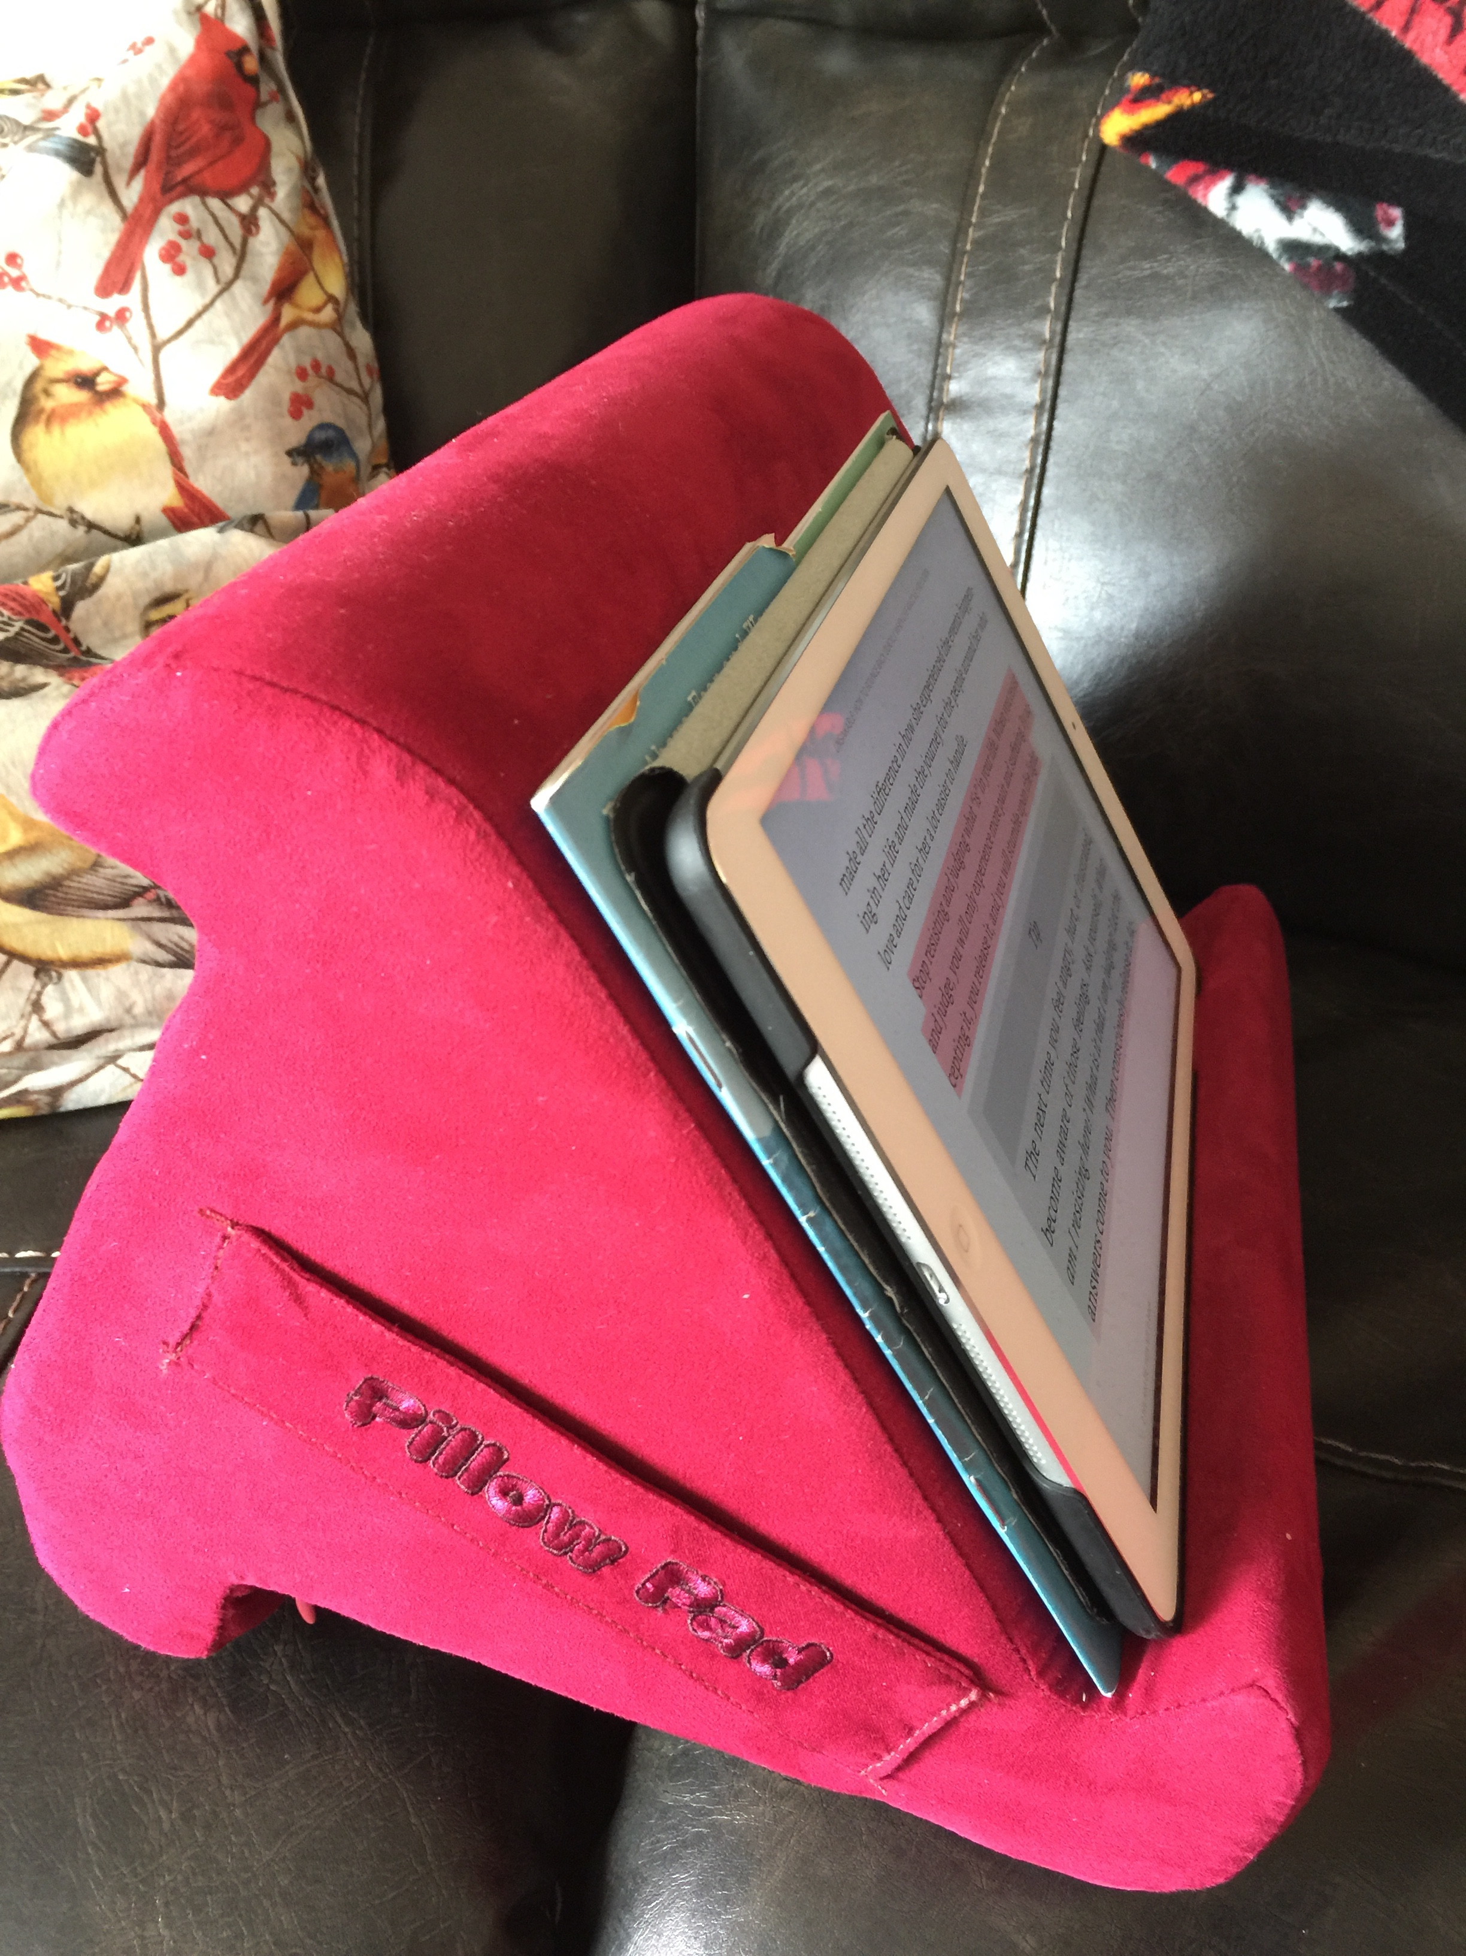
That’s about all for now. Stay in touch with any questions or concerns. Love to all, Abbie

