Update - Spring 2019

Hi all, I’m now out of the original batch of guidebooks and have ordered a bunch more - due in today or tomorrow. I did change the cover color from the dark orange to a nice green.

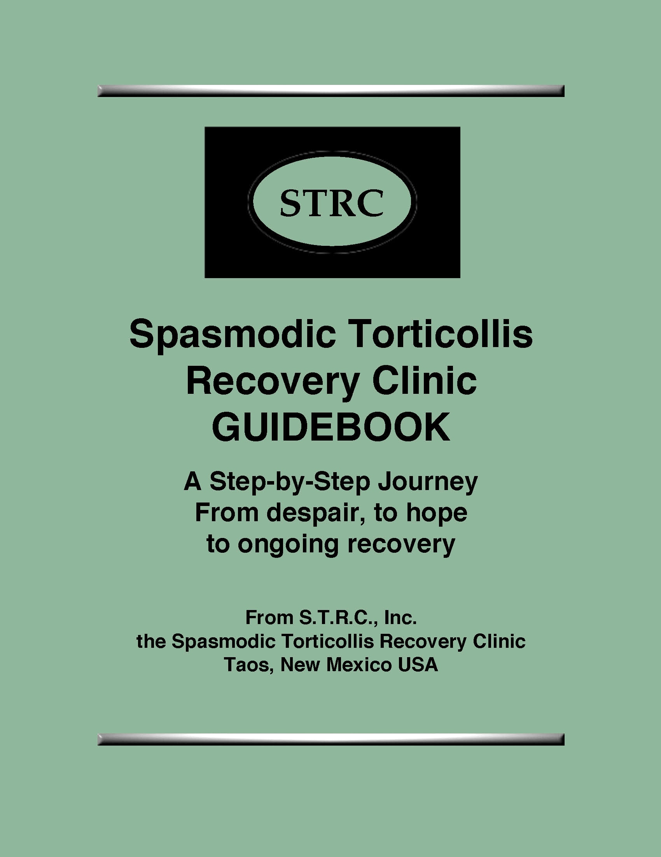

I made one edit. For those of you who have ordered it, the edit is on page 153. I added this to that page:

Here are you Four Basic Assignments:
1. Elongate muscles in neck (with military) and down back and across
shoulders. More elongation on short side.
2. Reprogram jaw with the Eeee.
3. Decongest EOP area with bodo and knuckle massage and both Head
Harness and Foot Strap.
4. Work on posture – gentle military, chin tucked a bit

And don’t forget about the Drop & Roll. Stand with your back against a wall. Move your neck toward the wall, chin WAY down doing the Eeee. Now drop your head forward, relaxed. Then tuck your chin hard and with the chin tucked move neck back to touch the wall doing the Eeee (with your chin still down ). Now try it standing away from the wall and sitting in a chair. You can do this off and on throughout the day.
**********

I know I’ve mentioned the Drop and Roll several times but it bears repeating. We all learn through repetition.
just go ahead and order via PayPal using our email with them stclinic.info@gmail.com Go to PayPal.com and hit the SEND button at the top. Then hit Send Money Then you’ll need to sign up to send money to the clinic. OR send a check made out to S.T.R.C., Inc. to me at:
S.T.R.C., Inc.
1335 Paseo del Pueblo Sur #259
Taos, NM 87571
You could also go to our Homepage and hit the Donate button to send the money. Either way, as soon as payment is in, I’ll send the book right out to you. Hope you like it!
On the personal front: I thought I’d obtained a loan but it fell through - however I finally did get a secure loan and the house has been ordered and the foundation will begin soon. This has been such a looooong frustrating 7 months Because STRC is basically a ministry, I take a low salary of only 30K a year, and the loan companies didn’t like that. So, the future looks promising and hopefully within a couple of months, I’ll be able to begin taking In-House clients. Maybe that’s overly optimistic, but I’m so anxious to get back into a normal life. Winter is over - good riddance, and it’s a joy to see spring exploding all over town. That’s all for now. Keep working, keep trusting and know you are loved. Abbie

