Update
Hi all - BIG NEWS! The Guidebooks are in. Here is the cover, and you’ll see that reflected on our Long Distance page on the STRC website for the Long Distance course.
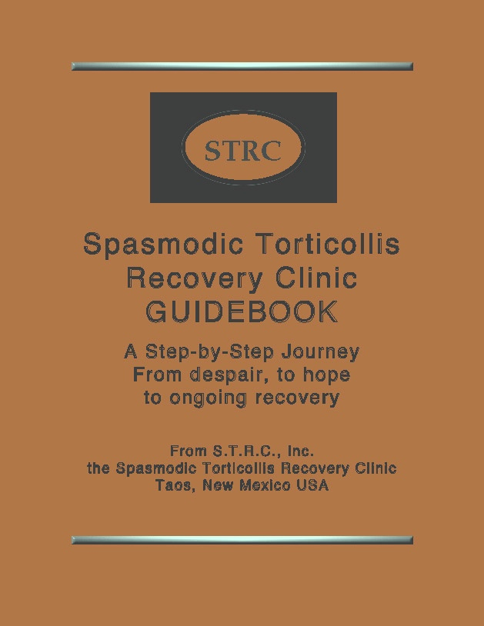
It’s 73 pages longer than the Previous Manual, and I’m so delighted with the way it turned out. My entire life’s work in a book!! I want to be fair in the cost to those of you who want to buy a copy. I’ve spent endless hours almost daily for many months to complete it, made a couple of trips to Santa Fe to confer with my publisher and just received 40 copies today with an invoice for the cost of the books and a hefty postage cost. PayPal also takes a fee out of anything paid to the clinic using their service, so we don’t receive the entire amount. Because its longer and heavier, it will also cost me more to mail it out and each one will require a trip downtown to the Post Office. So…. Given all of that, I feel the least I can charge for the guidebook to CLIENTS ONLY is $50.00. That will include postage for all within the United States. For those in Canada, please add an additional $20.00 and for those in any other part of the world please add an additional $30.00 to cover the additional postage. If anyone would like to donate a bit more, that would be deeply appreciated! Please remember that the book is copyrighted, and thus no part may be duplicated for any reason, either online or in hardcopy and may not be sold. Thanks so much for honoring this!
I hope this will be a blessing to those of you who order one, and I’d love to have some feedback. Thanks so much! Love, Abbie

