Update

Hello all,
Report on clinic’s future:
At this point in time, after talking with my Board of Directors who are such a blessing to me, I realize that I simply cannot afford to salary someone else at this time and not sure that will be realistic in the foreseeable future. I’m getting a strong sense that my new and probably final assignment is to do a complete clinic guidebook with 2, possibly 3 DVDs that will update and present everything I’ve learned over the last 32 years. It will be much more comprehensive and complete than what is currently available and will replace the Long Distance program. It will combine the In-House and Long Distance programs along with all the counseling and much additional information. Then when I pass on, if someone wants to do an In-House clinic, that person will have the entire blueprint, and long after I’m gone, future generations of ST’rs around the world will have access to our entire program, with no counseling needed, as it will all be included in the book. Once that is completed, I will no longer take In-House clients, as I will be in my 80s. I have a title and am beginning to work on an outline:
SPASMODIC TORTICOLLIS RECOVERY CLINIC GUIDEBOOK
A journey from despair to hope to ongoing recovery
Once I’m gone, members of my Board will probably oversee the printing and distribution of the Guidebook. I’m so excited about this project! Right now I’m very busy with clients coming in and Long Distance clients as well – a full work load with not a lot of extra time to work on the book. Once in Taos, I doubt if there will be as many In-House clients (as Taos is a 3+ hour drive north from Albuquerque) and will have more time to devote to the book. All of this is inside information; please do not put this info on any social media or in support groups. It will only be announced when the book is done and ready for distribution. Thanks.

Report on new home:
My house here in Santa Fe is on the market but only one looker so far. I’m trying not to be discouraged and simply can’t afford to keep lowering the price (which has happened twice so far). I’ve found a nice acre of land in Taos (4 miles from downtown) with all utilities and have chosen a nice modular home. It will be a lovely and comfortable venue for the clinic, – but nothing can be done until my home here sells and I have some money. It’s all a bit overwhelming to be going through this alone but just taking it one day at a time. Unfortunately, I’ll end up with a mortgage again but having to trust it will come together with the timing and finances. WOW – big changes! I’d appreciate your prayers. Thanks! My wonderful 18 year old Purry Mason went to kitty heaven a couple of months ago, and I am animal-free for the first time since 2001. I’d recently adopted an adorable 3 year old 3 legged Bassett Hound, but she was so bored here, so I found her a great and more entertaining new home. I miss having a pet, but life is less complicated now and no more vet bills!.

Clinic Business:
There isn’t a lot to report this time. A reminder for those of you who have not as yet purchased the Kneading Fingers and want one, amazon,com now carries it with free shipping if you are a Prime member. Please go to www.smile.amazon.com and type into the bar Spasmodic Torticollis Recovery Clinic Then bookmark that page. The clinic will receive a small donation with every purchase, and every little bit helps. Thanks so much. For those of you who have had the Kneading Fingers for awhile – a few years – you may have noticed that over time you will wear a small hole in the black cloth. Clark will sell you a replacement cloth and balls with instructions on how to insert that, however last time I got a hole, I just got some heavy black thread and darned the hole and – voila! - hole repaired.
A reminder too that if you’re interested you can get some PainCakes These stick on the skin and stay cold for a long time. Each one is supposed to be good for 100 sticks. I use them on my low back and knee that had the meniscus tear. Great product. Here is a link:
https://smile.amazon.com/Round-Reusable-Packs-Cloth-Backing/dp/B00XM1JI48/ref=sr_1_2_a_it?ie=UTF8&qid=1528495280&sr=8-2&keywords=pain+cakes
They are probably too icy for the neck. The Elasto-Gel Cervical Neck Wrap is best for your neck.
Reminder: if your back is tight, it will adversely affect your neck, so be sure to faithfully do your back work – some of the best exercises are the rower or seated row and/or row you do with a partner, Bend Hang, Cross-Legged Body Curl, and in the Gym the Lat Pull Down Rear and Seated Pull with the bar. Or you can relax your head and hang from a bar like we used to do as kids on the playground. Remember how important the Head Harness is – by far my favorite tool for elongating those short muscles in the back of the skull, neck and down the upper back. You don’t want to use a heat wrap on your neck but heat for the back is so helpful. With the Stenosis I use some back heat nearly every night and use a heated mattress pad (Beautyrest is the best one).
Thank you for your prayers for Gabi in Slovakia; she is having major breakthroughs after months of recovering from a broken collarbone – which threw her neck out. So even if you’ve recovered and have an accident you can plug into the program again and get back where you were.

A word regarding electrolyte imbalance: electrolyte imbalance, whether too much or too little, can be quite detrimental to your health. Muscle contraction, for example, requires calcium, potassium and sodium; deficiency may result in muscle weakness or severe cramping. Too much sodium, on the other hand, can cause high blood pressure and significantly increase your risk of heart disease. Don’t get too worried about maintaining your electrolytes, as electrolyte levels are mostly determined by food and water consumption so keeping the right balance simply comes down to proper nutrition. Here is an excellent page on this subject: https://www.builtlean.com/2012/11/28/electrolytes/ Bottom line, I strongly encourage you to eat properly, avoid junk food and chemicals and take Shaklee Vitalizer. It’s made from food and will give you the balance you need. (More per-review and clinical studies than any other supplement I know of) One of the symptoms of electrolyte imbalance is Muscle aches, spasms, twitches and weakness!!! See this page for other symptoms of imbalance: https://draxe.com/electrolyte-imbalance/ It’s possible to get a Electrolyte Panel Blood Test.

Attitude is so important! Our brain is hot-wired to our immune system. Faith is defined as believing in what we don’t see. “As a man thinketh, so is he” Proverbs 23:7 Do your best to speak positives laced with hope and thanksgiving. I know how hard that is to do when you are suffering, but it’s part of the healing process. Speaking negatives and hopelessness never makes us better.

Last of all:
This is something wonderful a client shared with me. Years ago I remember hearing a teaching tape entitled “We are all cracked pots”. None of us is perfect and we’re all a work in progress – right? – but those cracks are where God’s light can shine in. I was talking about that with a client who told me this.
In Japan, there is a technique to repair broken pottery called
kintsugi: https://mymodernmet.com/kintsugi-kintsukuroi/
Ephesians 2:10 (KJV) “For we are his workmanship, created in Christ Jesus unto good works, which God hath before ordained that we should walk in them.”
The Greek for workmanship is Poema - or work of art - with our cracks filled with the gold of His forgiveness and love to create an even more beautiful pot in His sight.
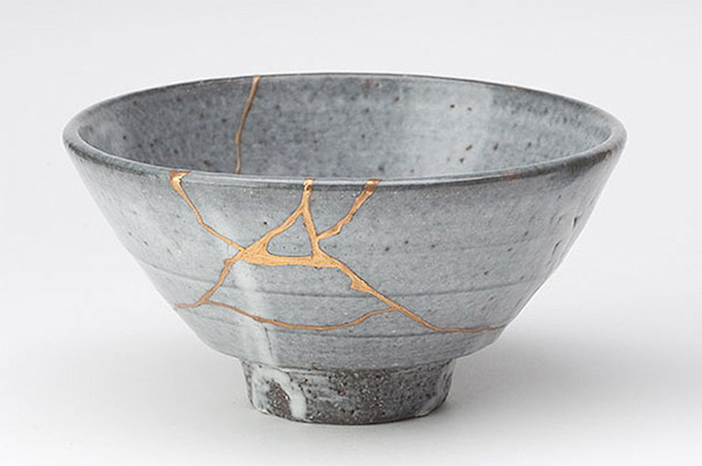
God bless all of you – fight the good fight and know you are loved and treasured.
Abbie

