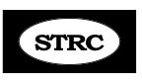
Update April 2018

Hi all,
First I wanted to pass along this amazing photo – of a client with very severe Retrocollis – as his head rolls extremely back. He devised this trick to lengthen his short head and neck muscles, by wearing the harness and then gently pulling down on the chain to pull his head forward. I believe that in a short period of time he will be able to use the harness the way we use it attached to a floor cable. I thought this was brilliant!
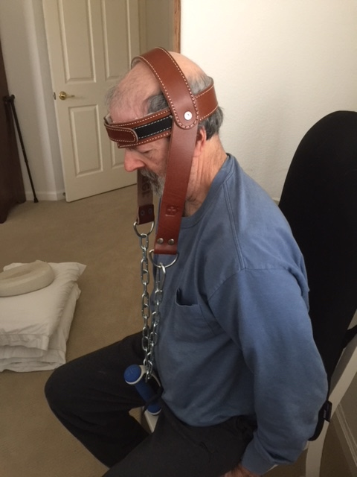

And now for some major news. Please keep this news between us, as I’m not ready to make it public, so please don’t discuss this on forums, bulletin boards, etc. It looks like I will be moving to Taos, NM, about a 90 minute drive north with 30 minutes of that being through a beautiful 2 lane mountain pass. This is one of the most beautiful drives in all of NM but on heavy snow days, the pass can be nearly impassable. There is airport shuttle transportation from Albuquerque Airport to Taos four times daily for the 3 hour ride. Once settled I’d be willing to continue to take In-House clients for as long as I am able and of course the Long Distance Program will continue to be available. On Monday I put a down payment on a beautiful acre of land with all utilities – only 4 miles from the center of town and yet out in the country on a dirt road with stunning views of the mountains all round. I’ve picked out a manufactured home that will be placed there as soon as I can secure a loan – which is the biggest challenge. And my home home will need to be put on the market. I would like to be up in Taos by August, Lord willing.
My son Neil and his family live there with my grandkids, and they are insisting on having me nearby as I am nearly 80. If something happens to me, they both work full-time and cannot be going back and forth to Santa Fe to help me and deal with my home etc. I know it’s what I need to do for their sake, but it’s an emotional roller-coaster for me, as my life, my work, friends, church, my home etc. are all here in Santa Fe. It means leaving my life behind, but I need to have an attitude adjustment and get on board with this. The thought of packing up this 12 room home is daunting. I can’t afford to carry 2 mortgages, so the timing is tricky.
So…. Please pray for me for guidance, the right timing, the sale of my beautiful home and that I can quickly secure a loan. Thank you so much!
I need to find someone I can train to carry the torch forward with this clinic. I’ve been praying for a long time, and God answers prayer, so I know the Lord has spoken to one of you about this. You may doubt the call or feel it’s too much for you to handle – but when God calls someone to a work, He always provides all you will need in every area. We just cannot let this work die! It would break my heart! I will train you, and the Lord will guide you and provide for you. When the Lord called me to start a clinic, I knew nothing! My husband and I were in missionary service earing $400.00 a month and praying in money for food and bills. All I had was an old electric typewriter – that was it. But I knew it was His call, and bit by bit it has come together over the years. I had to figure everything out and lay the foundation with His help – so all of that is now in place. When the clinic began, I had no gym equipment and worked out of a tiny den. One day during the week, I’d take my client to a local gym where I’d teach the gym work, and we could use the pool and Jacuzzi. That went on for years until I was able to get a larger place and some gym equipment. So this can be done in very limited space. All you’d need to do is learn some of the details and simply be willing and committed. It’s very important to me that whoever takes over be a strong dedicated Christian, as I know this clinic in a God-thing and a ministry; you need to know Jesus personally and know how to lean on Him and to know that day by day He is with you leading you forward. It’s been a glorious adventure, and you will be missing the greatest blessing of your life if you do not step out of the boat onto the water and accept His call. You may feel inadequate, but all He needs is a willing heart and a simple “yes” and the way forward will be supernaturally charted for you. ST’rs are desperate all over the world, and you could be the one to carry on and give them hope and what they need to come into recovery and get their lives back. The joy and fulfillment that brings is indescribable. I’m amazed and inspired by the work Gabi and Firman are doing in Slovakia and Indonesia. They said “yes” and God is providing for them. Here is a before and after of one of Gabi’s clients – can you imagine how she feels!?
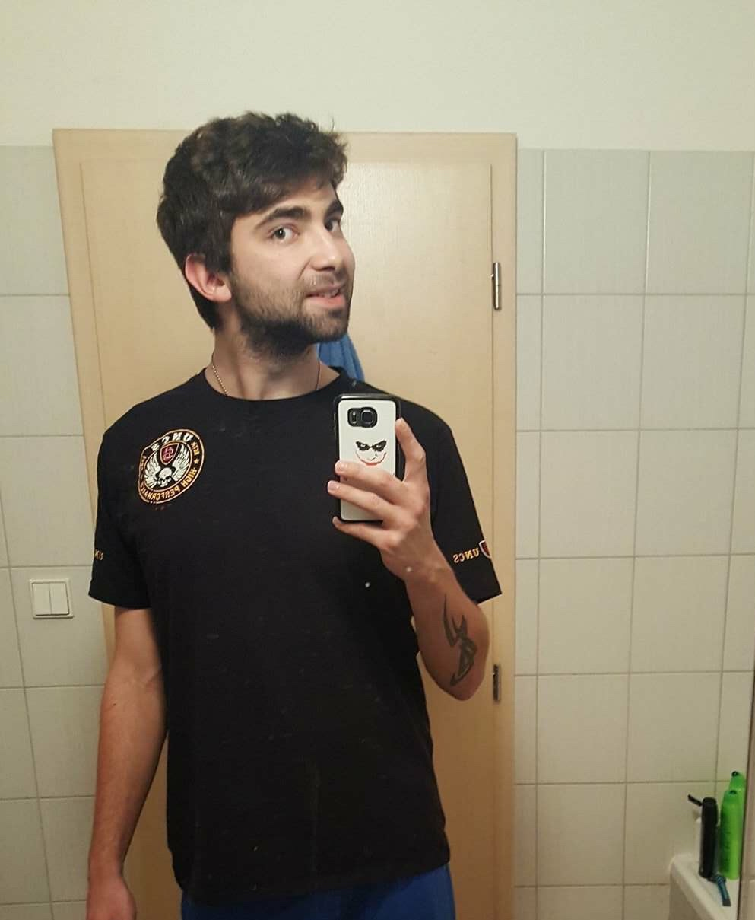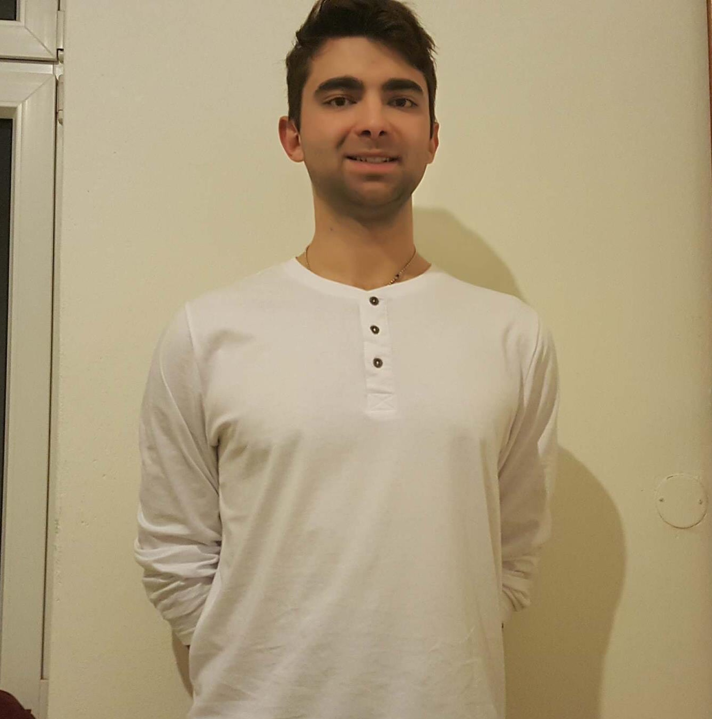

And so, this update is a call to prayer. If the Lord has called you, I need you to answer the call and get in touch with me. Also please pray for me regarding this huge move to Taos. Thanks. Love to all, Abbie

