Hi all, time for a New Year update. I pray this coming year will be a one of increased progress for all of you. First, I want to thank those of you who send end of the year donations. That is such a great blessing to me, not only because of the needed financial support but because it is so encouraging to have your support in general of our work here. Thank you again!!
REGARDING THE HEAD HARNESS, I have a hunch that some of you on the Long Distance Course are hesitant or afraid of the harness, but it’s my very favorite tool, and once you begin using it, I think you’ll agree with me. It’s honestly not scary at all and gives you an amazing stretch from the back of the head all the way down to the middle back. Just be sure to use it exactly as you see on the DVD. It can be a bit tricky to find online. Google Search for Harbinger padded leather Head Harness
Smile.amazon.com also has it, and that should be the first thing you see on the results of your search. Here is an image: you can see it has a strong Velcro closure - which is better than a buckle.
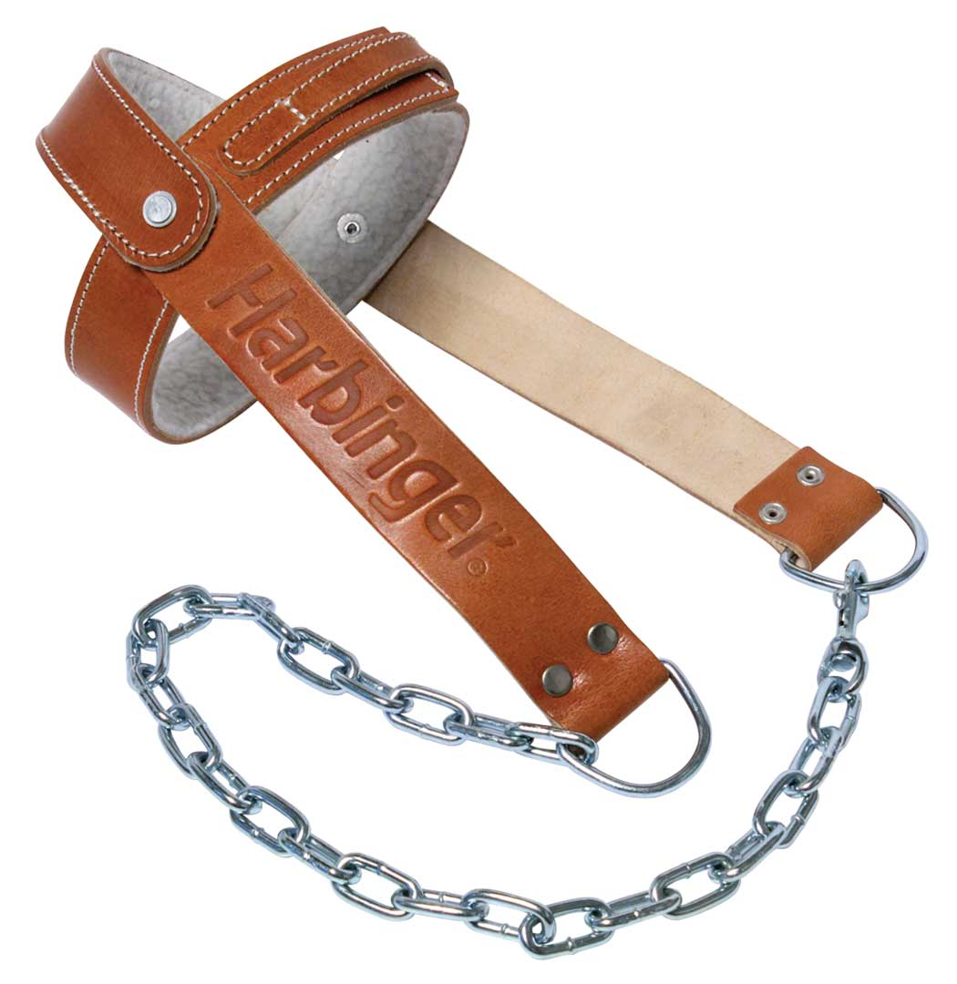
HERE’S A LITTLE TIP: and might be helpful for some of you; worth a try. If you are able, try walking around your house on your tip toes – maybe just a few steps. I find when I do that it puts me into an immediate gentle military and straightens my posture. If you like it, do it now and then.
PRODUCT IDEA FROM A CLIENT
“Don't know if you already have the Pure Wave Massager, but I got it for Christmas and the thing is wonderful. I got the most powerful type.
The percussion it does for the EOC area is FABULOUS. And when I use it on my neck, it immediately confuses the ST and my head is released!”

Pure-Wave CM7 Extreme Power Massager Body

https://smile.amazon.com/Pure-Wave-CM7-Massager-Shoulders-Black/dp/B019UFT420/ref=sr_1_4_s_it?s=hpc&ie=UTF8&qid=1515524193&sr=1-4&keywords=pure+wave+massager
I just bought this item, and it’s quite powerful; comes with 6 different heads. It’s over $100.00 and I’ve no idea if it will help everyone. It has a steady mode and a percussive mode. I like it but there are other items way more important - like the Head Harness, foot strap, Kneading Fingers if you live alone, and Accu-Ball massage tool.
BOOK RECOMMENDATION: as I’ve mentioned before I read The Brain That Changes Itself by Norman Doidge many years ago and highly recommend it. Here is his newest book: The Brain’s Way Of Healing. I’ve already downloaded it to my Kindle. Our attitude, how we think, what we say is SO involved in this healing process and his research is truly amazing. Available of course at smile.amazon.com
REST BREAKS: You need time to concentrate on your program - stretching with 2 or 3 rest breaks on the floor on your back, head on a pillow or two - for maybe 10 to 20 minutes. These rest breaks are to teach your body to relax - as a person with ST has lost muscle memory for relaxation. So the rest break is not just time off – it’s like an exercise to develop new muscle memory for relaxation. I find it helpful to watch something fun on T.V. or listen to a tape or something to keep your mind of you and the S.T.
MASSAGE IDEA: try massaging the area at base of cheekbone side of face with tips of four fingers (not thumb) One client found this would temporarily center her head. You can massage both sides of face at the same time. Again, these various tips may work for some and not for others.
Re MY PILLOW: as you know I recommend this pillow. I LOVE mine and now can’t sleep without it. Be SURE to get the premium. It comes with various levels of firmness. I use the White which is for almost everyone. Here is the color code breakdown.
YELLOW: for children (too soft for adults)
WHITE: average for most people (the one I use)
GREEN: Firm
BLUE: EXTRA EXTRA firm. Not for women.

REMEMBER, THIS RECOVERY BUSINESS IS A PROCESS! It takes many many months. I often get emails, especially from long distance clients who are frustrated after 2 or 3 months that they are not seeing improvement yet. You lay down an INVISIBLE foundation in the muscles for months before the body begins to get the memo that things are changing. It takes time for the body and brain to begin to work together and then initial breakthroughs come in small spurts and those good moments increase over time until those tight short muscles begin to hold the elongation. Patience and consistency are key!! Just plod along one day at a time, not expecting too much too soon. Don’t do too many reps or too much weight. Less is more. Use pamper tricks – rest, massage daily, hot baths or warm pool and Jacuzzi if available, cold packs for the neck and heat for the back etc. etc. Don’t let yourself say negative things like “this will never work”; your immune system is hot wired to your brain. Be thankful daily for improvement even when you don’t see it yet.
JUST AN IMPORTANT REMINDER: I will be 80 on my next birthday. I’m fine except for the stenosis which cause a lot of ongoing pain, so I can’t do this work forever. I can’t bear the thought of closing down the clinic, because people all over the world are desperate and need help and encouragement. So…. I need some help here. Please pray for me, for the clinic and for the right person to carry the torch forward. This has always been a ministry. It’s not a regular job but a calling and a passion and only needs a dedicated and willing heart. I am waiting for God’s call on one of you. Please get in touch with me if you have a hunch the Lord might be calling you to help. Thanks!
LAST OF ALL A LONG POST-IT REMINDER ON THE CORE OF THE PROGRAM:
People have asked me why this program works, and I have no proof for this, but this is my theory, and I believe it’s accurate. ST’rs produce too much Adrenalin and Acetylcholine in the brain; Adrenalin inflames both muscles and tendons, and it’s the Acetylcholine that flows through the nerves to the muscles setting off the spasms; it’s the substance that is being blocked by the Botox. One or more of the cranial nerves at the basil ganglia is misfiring, and this is the source of the problem though no one is yet sure why those nerves misfire (but it is related to the 5th nerve – see more on this below), and thus ST is considered idiopathic or without known cause, however ost neurologists believe it is genetic. My hunch is that the misfiring of the nerves then causes changes in the brain – which in our case produces too much Acetylcholine (which flows through the nerves into the muscles causing the spasms) and adrenalin (which enflames both tendons and muscles, keeping the spasms active). But there is also the reality of muscle memory and brain’s adaptation to the condition – for example our brains have learned that crooked is straight – so that when someone straightens your head it feels crooked. This program with the DAILY reinforcement of the exercises to lengthen the muscles and massage to break up scar tissue, detox the muscles and bring circulation and life back into the musculature, along with the nutritional aspects of the program to, again, detox and nourish the body – begins to, over time, as the body is reprogrammed, establish new muscle memory for normal and to actually create new neural brain pathways – the same thing that happens when you learn a foreign language or a musical instrument. In the surgery DBS, the Dr. drills down through the brain and lays a hair line electrode on the misfiring nerve and then puts things like heart pacers into your chest. When it works, it’s like a miracle, but is still experimental and potentially fraught with danger – you can be paralyzed, loose your vision or speech, etc. So far I’ve had 3 calls from St’rs who had that half million dollar surgery done and now it’s no longer working and they are back to square one. It’s tragic – but I know that some have been helped. When someone has had surgical intervention for their S.T., our program does not seem to be effective. So, when the surgery works, it could only work because by stopping the misfiring of the cranial nerve, then the overproduction of both adrenalin and Acetylcholine is normalized, and thus the symptoms disappear. Then why does the S.T.R.C. program work? Again, my hunch is that as the muscles lengthen and you begin to achieve bilateral equality in the neck muscles, and the head begins to straighten, a more normal flow of information up the spinal column into the brain begins to be re-established, which may very well help to normalize the misfiring of the cranial nerve, and thus normalize the excessive over-production of both Adrenalin and Acetylcholine, and so you are able to achieve a state of ongoing recovery from the symptoms. That is my only explanation as to why this program is effective. Recently there has been a lot of discussion in our field of the use of dental orthotics. The 5th or Trigeminal nerve is located in the jaw area and runs up into the basil ganglia. When you have ST, that nerve is pinched (due probably to the misalignment or tendency of our heads to jut forward, putting pressure on the jaw – many ST’rs complain of TMJ) The orthotic device appears to force the bones in the jaw apart a bit so that the 5th nerve has a clear path and can operate normally, but it can be hard to eat and speak with that contraption in your mouth. On our program when you use the Military Brace position with the Eeeeee, that accomplishes the same thing; you can feel it working the jaw area, and over time, it restructures that jaw area, allowing the 5th nerve to operate normally. The military elongates the short muscles in the back of the head and neck,and the Eeeee reprograms the jaw. This apparently is the key to "fixing" the abnormal misfiring of the cranial nerve, which then, in turn, normalizes the production of both Acetylcholine and Adrenalin, and then you can come into an ongoing recovery. Changes do occur in the brain. All of this works together to create a sort-of new reality for the body to live in that is normal. You still have ST, but you have replaced the phenomena of it with a new normal state of being. This will happen over time, slowly in bits and pieces IF you will do the program, but you must be diligent and not expect much at all at first. You will lay an invisible foundation deep within the muscles LONG before you actually SEE anything that could be called progress. I and others who have hung in there and kept up with the principals of the program can testify that this does happen, but we have to keep up with the program if we want to stay well. I’ve been living a normal life now for over 30 years but work the general principals every day. It becomes simply the way you live – like putting in your contacts everyday to see well. So I gave that background to say this; I believe our program is effective because you will spend months stretching, elongating and normalizing those spastic muscles, detoxing the body and feeding it what it needs and massaging to assist in the elongation and reprogramming process, and your alignment and posture will change over time. When all of that finally happens, I believe that proper circulation and exchange of info between the body and brain is normalized (after years of being compressed and pinched off at the EOP or occipital ridge) and that must, in turn, normalize the output of adrenalin and Acetylcholine and then you can come into what we call an ongoing recovery. But this must become a lifestyle. I still do my program to stay normal and feel good and function normally, but it’s a very small price to pay! Some client who come into recovery mode no long exercise or do the massage work but they do follow the postural alignment, sleep mostly on their back, avoid the no-no medications, and avoid activities that can bring back symptoms – like anything that juts the head forward, rolls the head back or can cause an accident or stress on the body like many sports activities can do.

Love to all of you, Abbie

