Hello all,

We’ve had a loooong Indian Summer here and so grateful not to be fighting snow yet. Lot’s of items for this update.
First of all some major news. Many of you may already know that the national organization ST/Dystonia will be closing it’s doors Dec. 31st. Howard has been diagnosed with throat cancer and heading into weeks of radiation. His organization has been around since before I began the clinic - so over 30 years - first as NSTA and then he left that and turned his Wisconsin support group into ST/Dystonia. He’s been there for decades supporting and encouraging ST’rs . The end of his organization will leave a huge hole in the ST community. Please be in prayer for him. The NSTA is still in operation: http://www.torticollis.org/

Here is a nice update from or Director in Indonesia:
Just fyi that the owner of the place (Christian) which I am about to rent, is not willing to set the price for the rental.
She still remembered me when I was still sick last time and I told her about my intention with STRC Indonesia.
She told me that I can just use the place and pay her as I can so that I have no pressure in paying for the rent at all.
The location is in the central of Jakarta and in fact, it is quite a popular area for those who are not staying around Jakarta.
It is a God's Grace and I am so blessed with all these nice people surrounding me :-) .
strcindonesia@gmail.com
Regards
Firman Rusli

Tom Seaman sent me a page for his blog with some interesting products. Sitting up erect at your computer is best, but some ST’rs just can’t do that and he has a suggestion here: http://dystonialiving.blogspot.com/2017/07/relax-while-you-work.html

Product Info: some of you have asked what gravity table I got and here is the link. I trust Teeter but Ironman is a fairly good brand as well. I don’t use the little colored trigger point balls that came with it – felt like rocks. https://www.walmart.com/ip/Teeter-EP-960-Ltd-Inversion-Table-with-Back-Pain-Relief-Kit/117693299
Here is the same model on ebay, new for less money. https://www.ebay.com/itm/Teeter-Hang-Ups-InvertAlign-900-Inversion-Table-Brand-New-IA1009/262925256776?epid=730993072&hash=item3d37910848:g:FhgAAOSwhTVZznH~

The Accu-Ball massage tool is a favorite of mine and inexpensive. Here is a demo: https://www.youtube.com/watch?v=vp5HpaHZsRE
If you are blessed with someone at home who can give you ten minutes or so a night of massage, you don’t really need any tools. For massage.
I also love the Occipivot and use mine every night (20 minutes max) Here is a video demo for that: Occipivot use video: https://www.youtube.com/watch?v=Jay0Z88rS1g

Paincakes: As you know I recommend cold packs for the neck (heat for the back) and for clients here I use the Elasto-Gel Cervical Neck Wrap. I recently found a new product that you can stick anywhere. With my knee and Stenosis back problems I use these often. They are gel packs so icy cold (whereas the elasto-gel wrap is a cloth soft cold) They are called Paincakes – the ones I got are round and 5 inches across. https://www.thegrommet.com/paincakes
Here s a video demo: https://www.youtube.com/watch?v=48fMWSzKnIs
I got the 3-pack: https://www.thegrommet.com/paincakes-reusable-adhesive-cold-pack-3-pack

Joint and Muscle Cream: I’ve mentioned this before, but it bears repeating. This is the ONLY topical pain relief cream I’ve ever found. It calms down pain for awhile.
MAX 88 JOINT AND MUSCLE CREAM http://www.qvc.com/DrPaulNemiroff-Joint-Formula88-Max-Plus-Muscle-Ache-%26-Arthritis-Cream.product.A218303.html?sc=SRCH

Massage: here is a move I always do with In-House clients, but for Long Distance Clients, you haven’t seen this and it’s so helpful. Enjoy:
Skull rock Massage Demo: https://youtu.be/EGXKHi4NdYo

Regarding eating: I know it can be so difficult to sit at a tible and eat without leaning into the plate. I know this sounds weird, but try putting a cardboard box on the table- maybe 2 feet high or close to that. Put the plate on that so you won’t lean into your food. Ditto for reading. If sitting in a chair put a few pillows on your lap and put your book or work ontop of that - bringing the work high up toward you. This will help your posture and keep you from curling into your work.

Donations to the clinic are always needed and so gratefully accepted but here is a way to donate just by using amazon.
Please use www.smile.amazon.com This a wonderful amazon program for non-profits. S.T.R.C. will receive a small % of whatever you spend on amazon by using smile.amazon.com Go to www.smile.amazon.com and sign in as usual using your amazon email and password. Then you will see a bar where you can select an organization: type in Spasmodic Torticollis Recovery Clinic Hit Select and begin shopping! BE SURE to bookmark smile.amazon.com Then every time you go there, you’ll see it will say you are supporting the clinic. I have it on my toolbar where it’s always available. This won’t be connected to you or any of your personal info. THANK YOU SO MUCH!!!

On a personal note: I’ve had 2 recent miracles – one small but very important to me as it has been a huge stress reliever! I finally found a home for my bratty cat Otis who was attacking my other cat and driving me crazy. The woman who adopted him is a saint and I’m so grateful. The other miracle is HUGE. My younger son, Neil, married Shauna many years ago. She was the daughter I never had. I adore her and she is such an awesome Mom. There were married 9 years and then divorced. The grief was overwhelming for the entire family but especially for their two children. I’ve prayed everyday for 5 years – lots of tears and pain all around. Then in August Neil, Shauna and the kids flew up to Las Vegas for a fun 4 day adventure – zip lining etc. and on the 4th day, surprised the kids with a limo ride to Precious Memory Chapel where they were remarried!!! Again, lots of tears but happy tears this time and so grateful to the Lord for such an amazing answer to so many prayers.
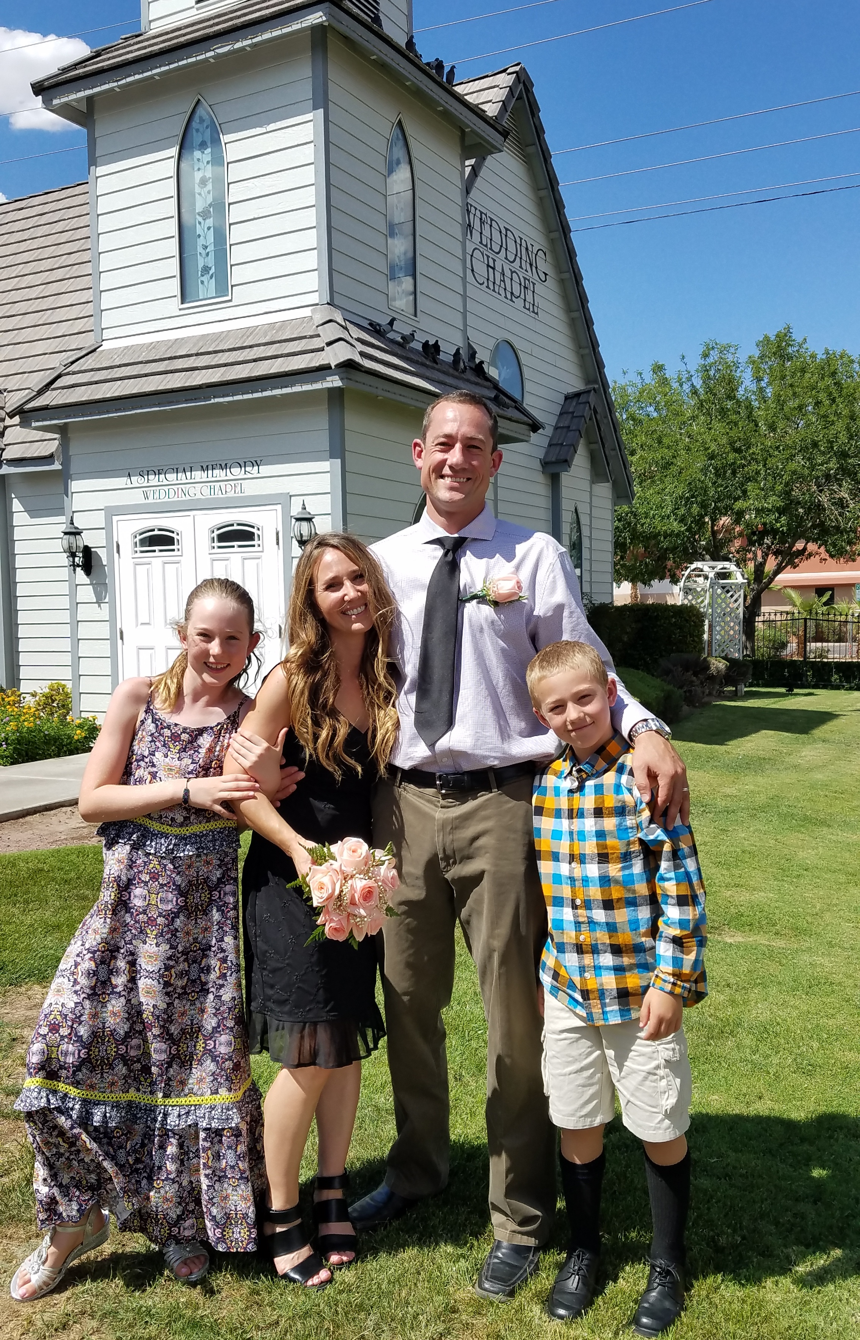

If you’ve made progress and haven’t sent me an updated photo, I’d love to see one!! Thanks so much! Here is a wonderful before and after from a Long Distance client in India.
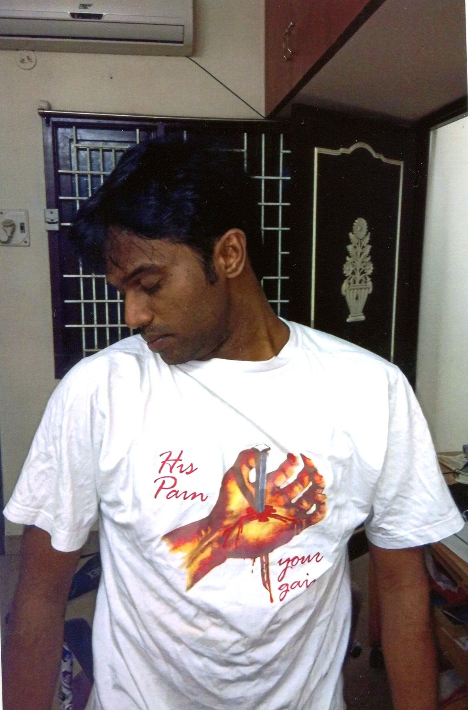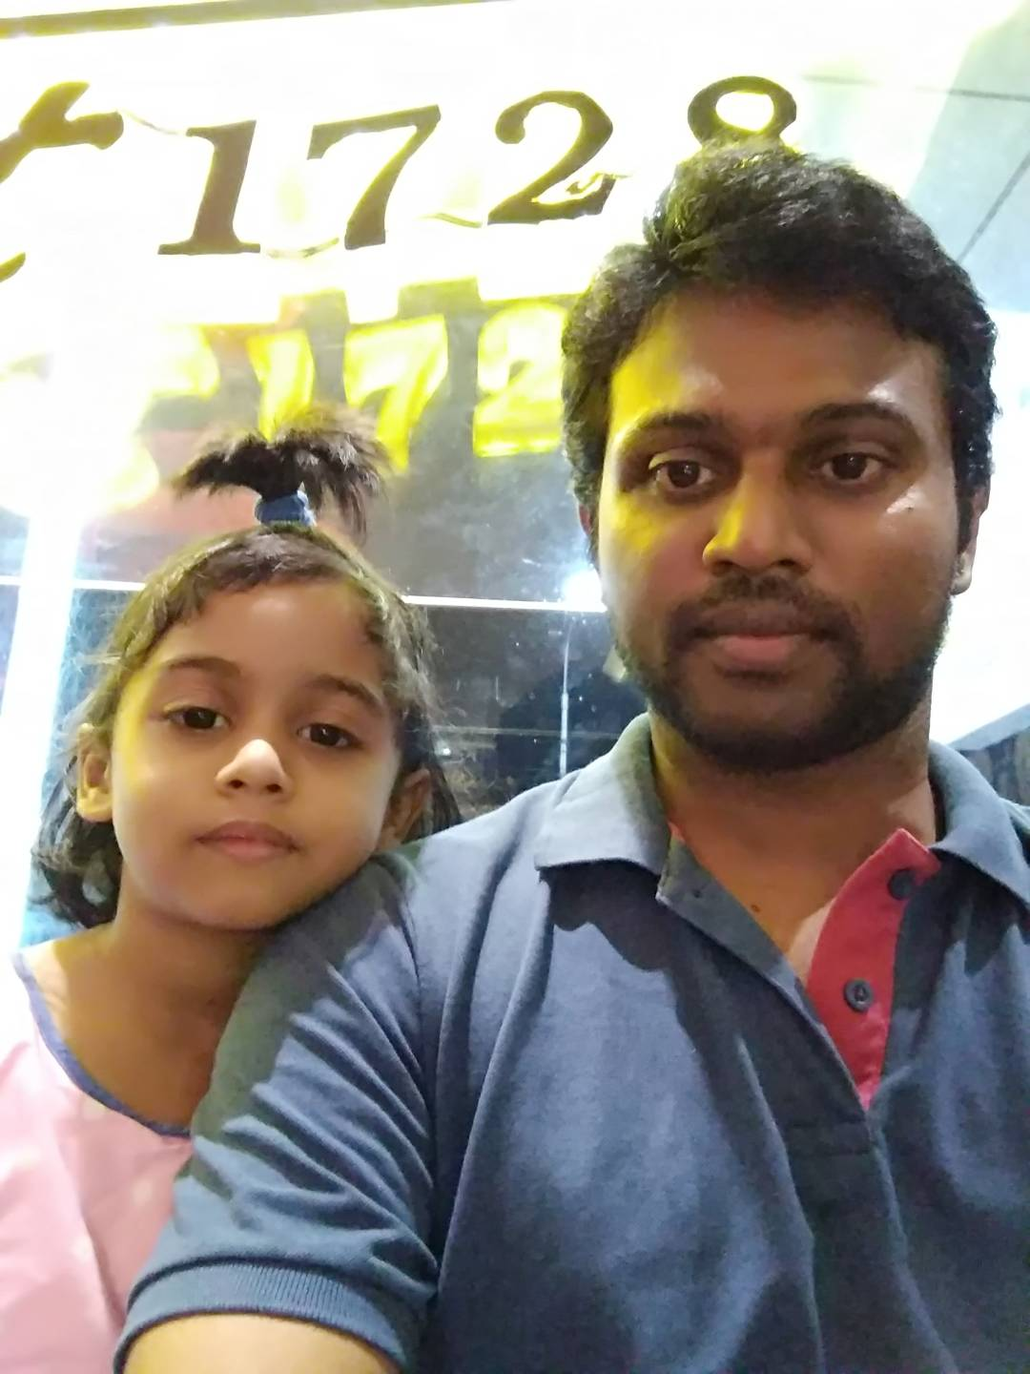

Remember the importance of baby-stepping with the program and doing your best to stay positive. Saying negative things isn’t good for your immune system or your heart or your spirit. Know that you are loved.
For those without computers, please try to find a friend who can show you all the links on their computer. If you have an email address, please let me know.

God blessings to all of you, Abbie

