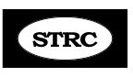
Update Spring 2017

Hi all, this is going to be a big update, so grab a cup of coffee or something healthy and enjoy.

First of all – drum roll….. ON MARCH 1, 2017 S.T.R.C. OPENED AN AFFILIATE IN SLOVAKIA!!!! The Director is Gabi Kissova, a Long Distance client, now in recovery mode. Please go to our website, stclinic.com and you’ll see the announcement on our homepage with a link to a page with more details and her before and after photos. Gabi speaks 4 languages fluently and will be able to care for ST’rs I could never reach. We are affiliated ONLY insofar as she is using our Intellectual Property (i.e. our program materials) Here is a comment from Gabi “This program gave me my life back Abbie, and I am so thankful to you for that, and I know it can change the life of others.” CONGRATULATIONS Gabi!!!!

This next item is for your discernment: Doctors Are Now Warning: If You Use Aluminum Foil, Stop It Or Face Deadly Consequences http://reflectionofmind.org/doctors-now-warning-use-aluminum-foil-stop-face-deadly-consequences/?t=eic
Testimony: We receive so many wonderful testimonies but this one is so extraordinary. A little over a year ago, I got an email from a woman in FL names Ale who has recovered on our program. She knows a family in Peru whose young son took some bad medication and ended up with what looked like a generalized Dystonia, but definitely also S.T. Because I don’t speak Spanish, I asked Ale to take charge and help direct little Luis and his supportive family through the program, so she kept in touch with them via email. When I saw the following little video it just broke my heart and they are very poor, so I scholar-shipped him the course and FedEx’d it down to Peru. Along with his happy recovered photo was this note from Ale: "This is the Peruvian kid that was so horribly affected!!! Thanks to you and your program he is now happy!!!! Very little shakes but can actually has a normal life!!! God Bless you Abbie and Merry Christmas!!!”
This was my BEST Christmas gift!!!
Here is a still of Luis before:
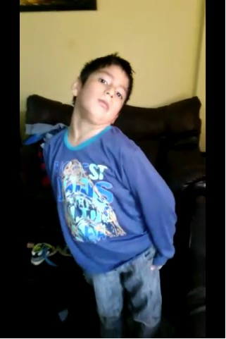
Luis in progress: Luis in recovery mode:
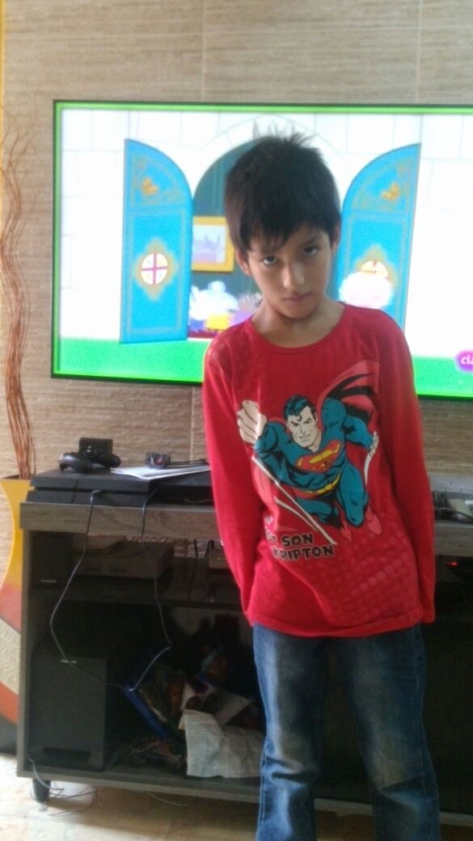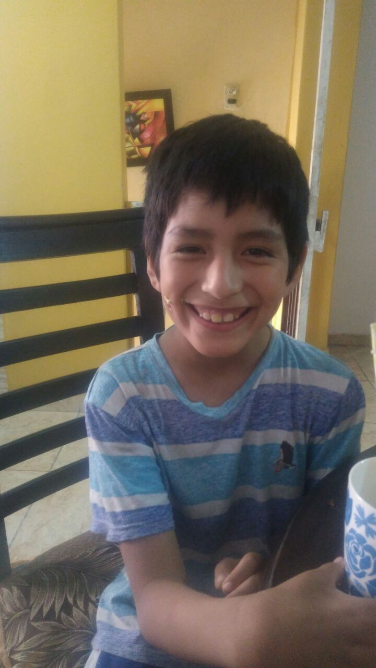

A note on the 1-900 Miracle book I wrote last year: it is now available in Kindle format on amazon.com You can continue to get the paperback here: http://abbiec5.wixsite.com/900miracle If you read it and like it, please consider leaving a review on the amazon.com page. Thanks! Speaking of books, I’m currently reading an awesome book, Josiah’s Fire, co-authored by a former client, Cheryl Ricker – also available on amazon.com It’s the true account of a severely autistic boy who, as just a little child, began getting messages from God and typing them on his Mom’s ipad. It’s honestly mind-blowing and so inspiring.

If any of you suffer from chronic dry eye, as I do, here is a simple and very helpful trick to alleviate the problem for periods of time. I use drops but on a bad day I do this and it really helps:
https://www.youtube.com/watch?v=CuL84LDCxsY

Here’s a note from a client FYI:
I wanted to let you know of a supplement that I have been using for two years now. It has not changed my ST but it did help with pain and achiness. I am using Ezorb ( a type of calcium from green plants) made in California. It is made by Elixir Industry. I first looked at the web site about 3 years ago but it sounded too good to be true and I was hesitant to try it. I finally got tired of the pain and I tried it. I could feel a difference in about 4 days. Just thought I would share that with you. Linda Holifield
*** Just a reminder that if you are not taking the Shaklee Vitalizer, I encourage you to begin using it. It’s so far superior to other types of vitamins: http://strc.myshaklee.com/us/en/

One of my favorite exercises - #1 part 1 – the Straight Chair Stretch: A reminder that the severe MB/Eeee is the wrench you use to change/reprogram the body. A gentle MB is just good posture, chin tucked a bit and used for maintenance.

A note on the Nikken magnets: Since I don’t really do Nikken as a business, I was unaware that they have new insoles. See them at www.nikken.com. Click on Shop Now and look on the left under Insoles for MStrides and MSteps. The MStrides are supposedly a bit thicker than the MSteps and both retail at $60.00 a pair. These are a bit stronger and improved over the older Magsteps and Magstrides. I ordered both and honestly can’t see any difference in thickness, so if you want some, I’d advise getting the MStrides. You can feel the little magnets on the soles of your feet and they are supposed to give you a nice massage as you walk. These are optional and not necessary to recovery! Here is a nice short video on the MStrides: https://www.youtube.com/watch?v=u8xQ4uN5T2I
If you want to order, do so by phone as on your resource page.
Order magnetics from Nikken: toll-free
1-888-264-5536 (that’s 1-888-2NIKKEN) Say you’re a customer and are paying retail.
Use ID# 133286500 under my name Abigail Collins (my legal name) The Nikkern Power Chip is also a great product – about the size of a silver dollar. Email me if you want more info on that item. You’d need the NikStix tape for those and the tape goes on the side with the little circles.

Back Work: remember how important back work is. If your back is tight, your neck will not want to release. For the back, here are some of my favorites, Bend-Hang, Cross-Legged Body Curl, Squats, Toe Tucks, Foot Strap, Rowing machine and Gravity Table. And don’t forget long hot soaks in a tub, or warm pool and Jacuzzi.

Back of the head and EOP: I feel it’s really helpful to make fists and scrub the EOP area and back of the head, especially on your short side vigorously for about 30 seconds. Do twice a day. If some of you would like to do this daily for a month or so and then get back to me with a report, I’d be very interested and will include the results in the next update. Thanks. God bless all of you. Never give up! Love, Abbie

