STRC Spring Update 2016
Hi all, several tid-bits to kick off the new year. I’m using my older clinic address of stclinic@comcast.net because my gmail clinic address may be a problem with MailChimp, but for emails to me in general please use stclinic.info@gmail.com. Thanks. .
First of all I want to thank those of you who have helped with your tax-deductable donations to the clinic. Every penny is so deeply needed and appreciated! I want to especially thank one of you who contributes anonymously through your employer each moth. I don’t know who you are but thank you so much!
The excellent website www.thefifthnerve.com has been taken down. I have no idea why. It showed the use of the dental orthotic. So many ST’rs are interested in that. It has helped some, but you still have a contraption in your mouth and it’s very pricey. The Eeee that you use with the military reprograms the jaw over time and does the same thing - without the contraption and the expense. Reminder that it’s the military that elongates the short muscles in the back of the skull and neck, and the Eeeee reprograms/realigns the jaw, freeing up the Trigeminal (5th) nerve. This is the core of our program!!!
Here are a few natural pain options. From a client:
I 've had good results with Joint FX from https://thepeopleschemist.com/?s=joint+FX
with no side effects, but it's expensive. After 6 months, all pain in my knees has disappeared, and the little loss of ROM has been restored. Now I only take the recommended maintenance dose. An Amish client recommended this:B and W ointment http://www.amazon.com/Burn-Wound-Ointment-Oz-Container/dp/B00LF0UNWO I personally use the following for stenosis pain, and it works well (and I also use magnets): Dr.PaulNemiroff-Joint-Formula-88-Max-Plus-Muscle-Cream Get this at www.qvc.com
Clever idea! Years ago Henk VanBeek, whose short video is on our homepage, arrived at the clinic wearing his Obusforme! He would stuff the little pillow into it as well and told me that, when wearing it, his head would be straight. It’s a tool he used to create new muscle memory for “normal” as he Worked into recovery.
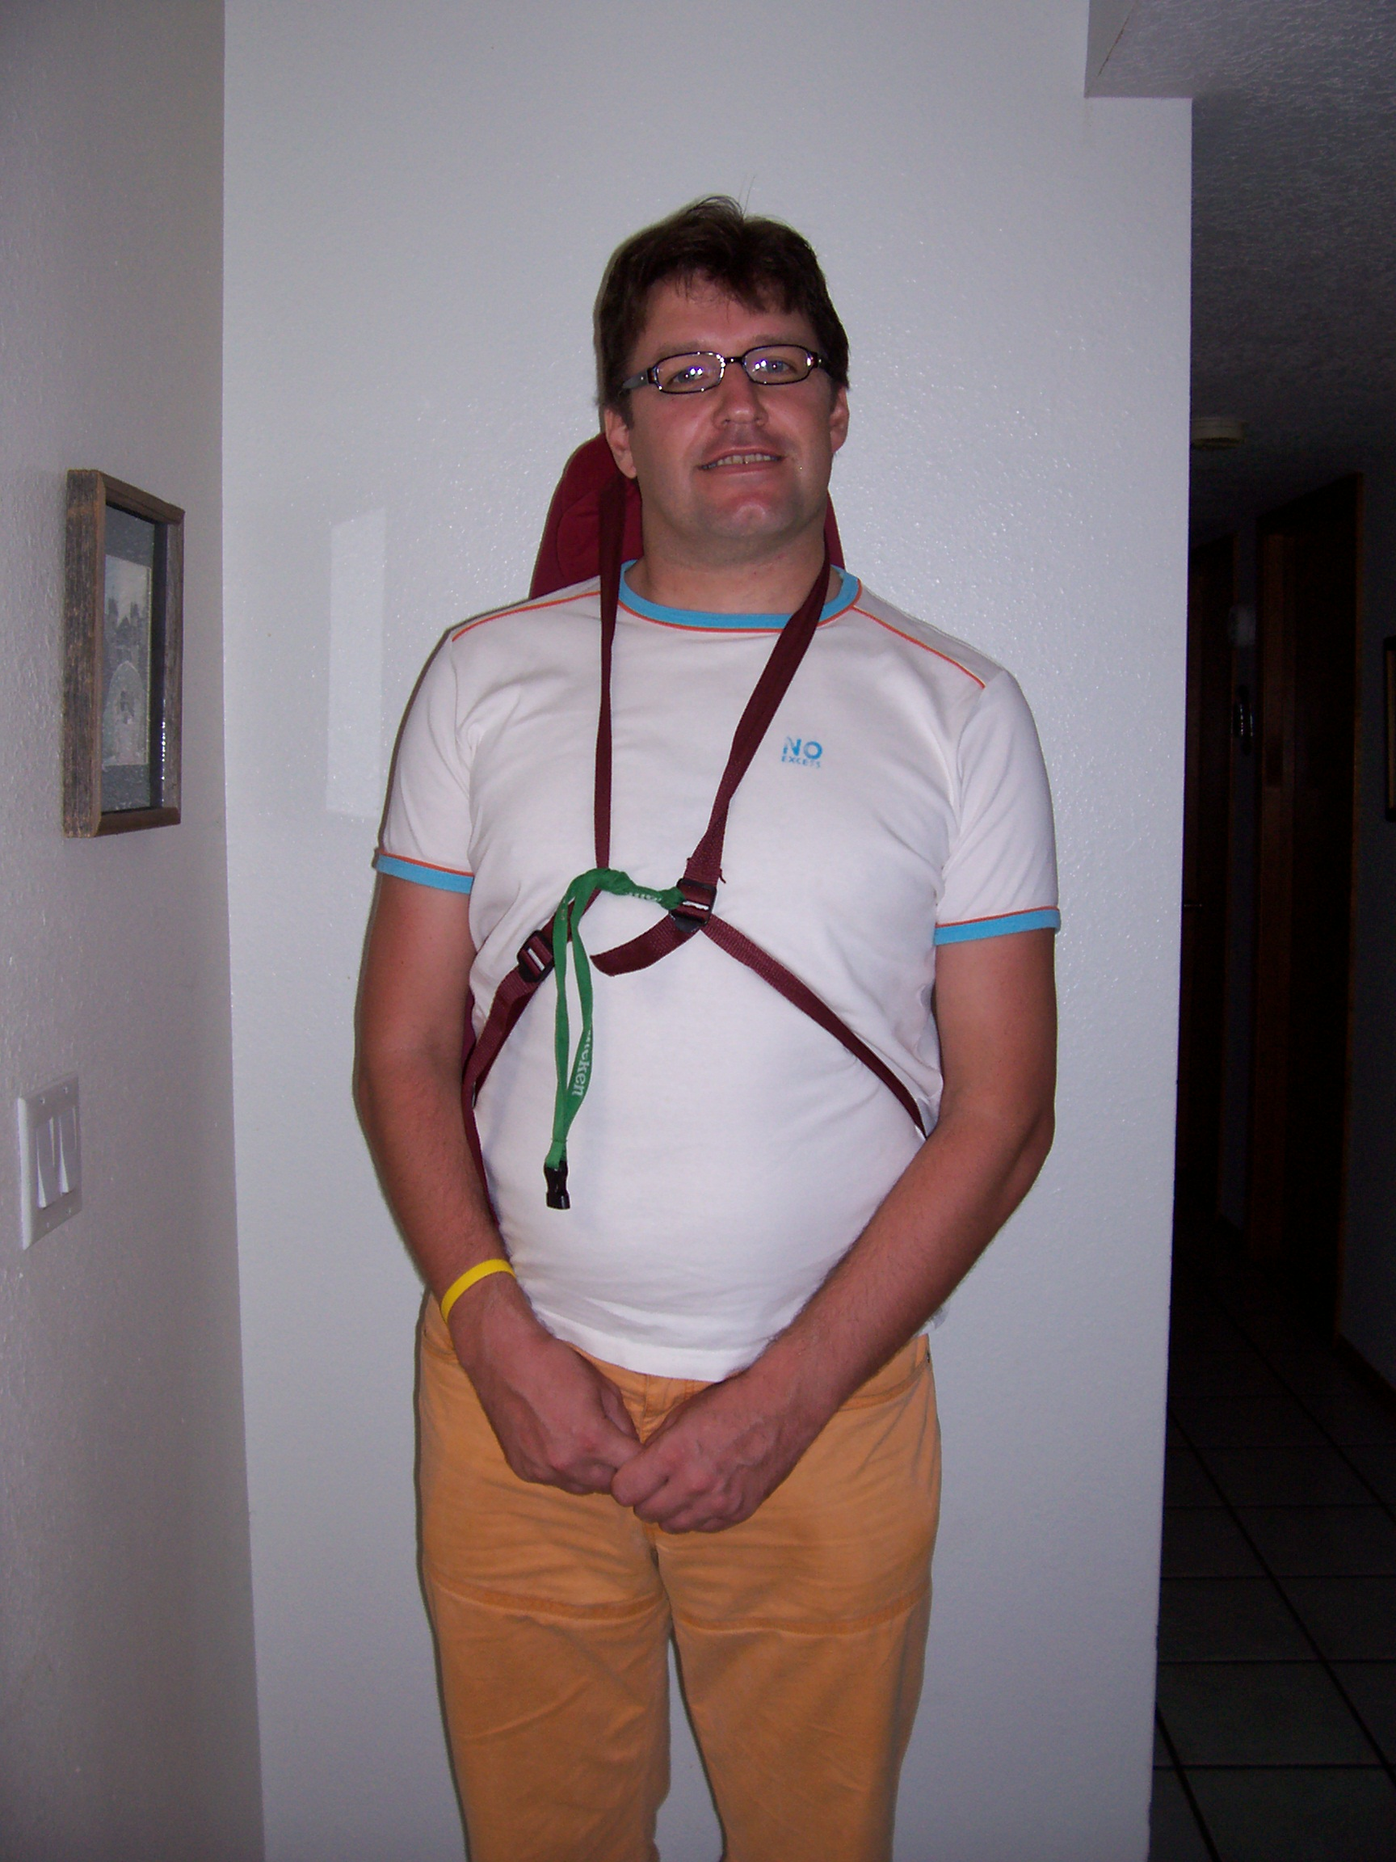
Interesting
A former client who has suffered with severe depression (not necessarily linked to ST) for years, finally discovered via genetic testing through a naturopath, that she has a genetic disorder called MTHFR. By avoiding processed foods, adjusting her folate levels and a bit more and in no time the world was sunny and all the depression gone. You can do your own test at www.23andme.com She had a stoke about 6 months ago that she feels was almost certainly related to this disorder and could have been avoided had she started the totally natural treatment earlier. Here is a site re. this disorder: http://www.globalhealingcenter.com/natural-health/what-is-the-mthfr-genetic-defect/ I’m sure most of us don’t have this, but it’s certainly worth knowing about the info.
The ST Facebook group going well but could do with more members. Here is the link to find the right group:
https://www.facebook.com/groups/1540050622951361/
or you can go the Facebook.com and type in Spasmodic Torticollis Recovery Clinic and you should find the page and then click on JOIN GROUP. This is a closed group for clients only.
Splenda dangers:
http://articles.mercola.com/sites/articles/archive/2011/09/20/why-are-millions-of-americans-getting-this-synthetic-sweetener-in-their-drinking-water.aspx?e_cid=20110920_DNL_art_1
Microwave dangers:
http://naturalsociety.com/microwaves/
I personally never use my microwave – ever for any reason. You can find articles on the web debunking this information, but I’ve read too much to substantiate it and won’t risk the potential serious health problems associated with microwaves. It seems that the way microwaved food negatively impacts your DNA is as or more dangerous than the radiation. When at a restaurant, I ask that my food not be microwaved; I’d rather wait a few more minutes.
And last is a photo of my family taken at Christmas up in Taos.
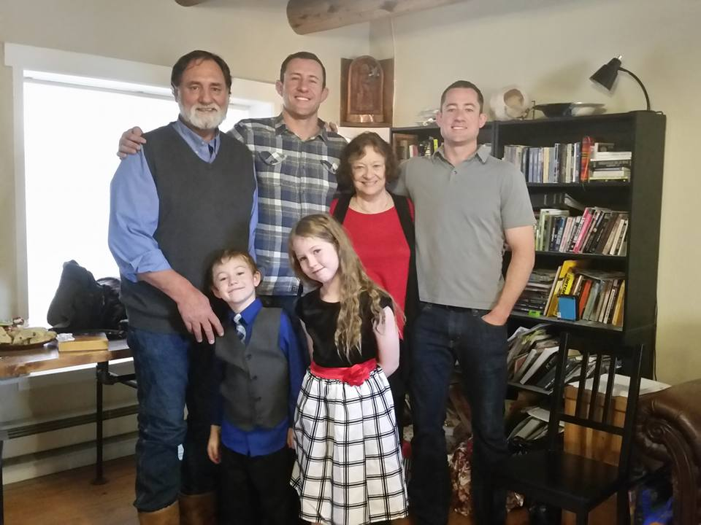

Please continue to work daily on your recovery and follow all the basics> your stretching routine daily – some weight work, practice the military/Eeee off and on during the day, watch your posture and your diet, don’t sleep on your short side, get some massage daily, even if only self-massage, and exercise your faith along with your body. Blessings to all of you.
Love, Abbie

