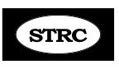____
December Update 2015 – Merry Christmas, Happy Hanukkah and blessings to all of you!

Hi all, this is a short update and our last one for this year. First of all, I want to thank all of you who sent good wishes and prayers after my launch into my hall table on Nov. 9. You saw the awful not a pretty woman photo in the last update. Here is a new revised one taken Thanksgiving day with my Grand kids. All healed up!
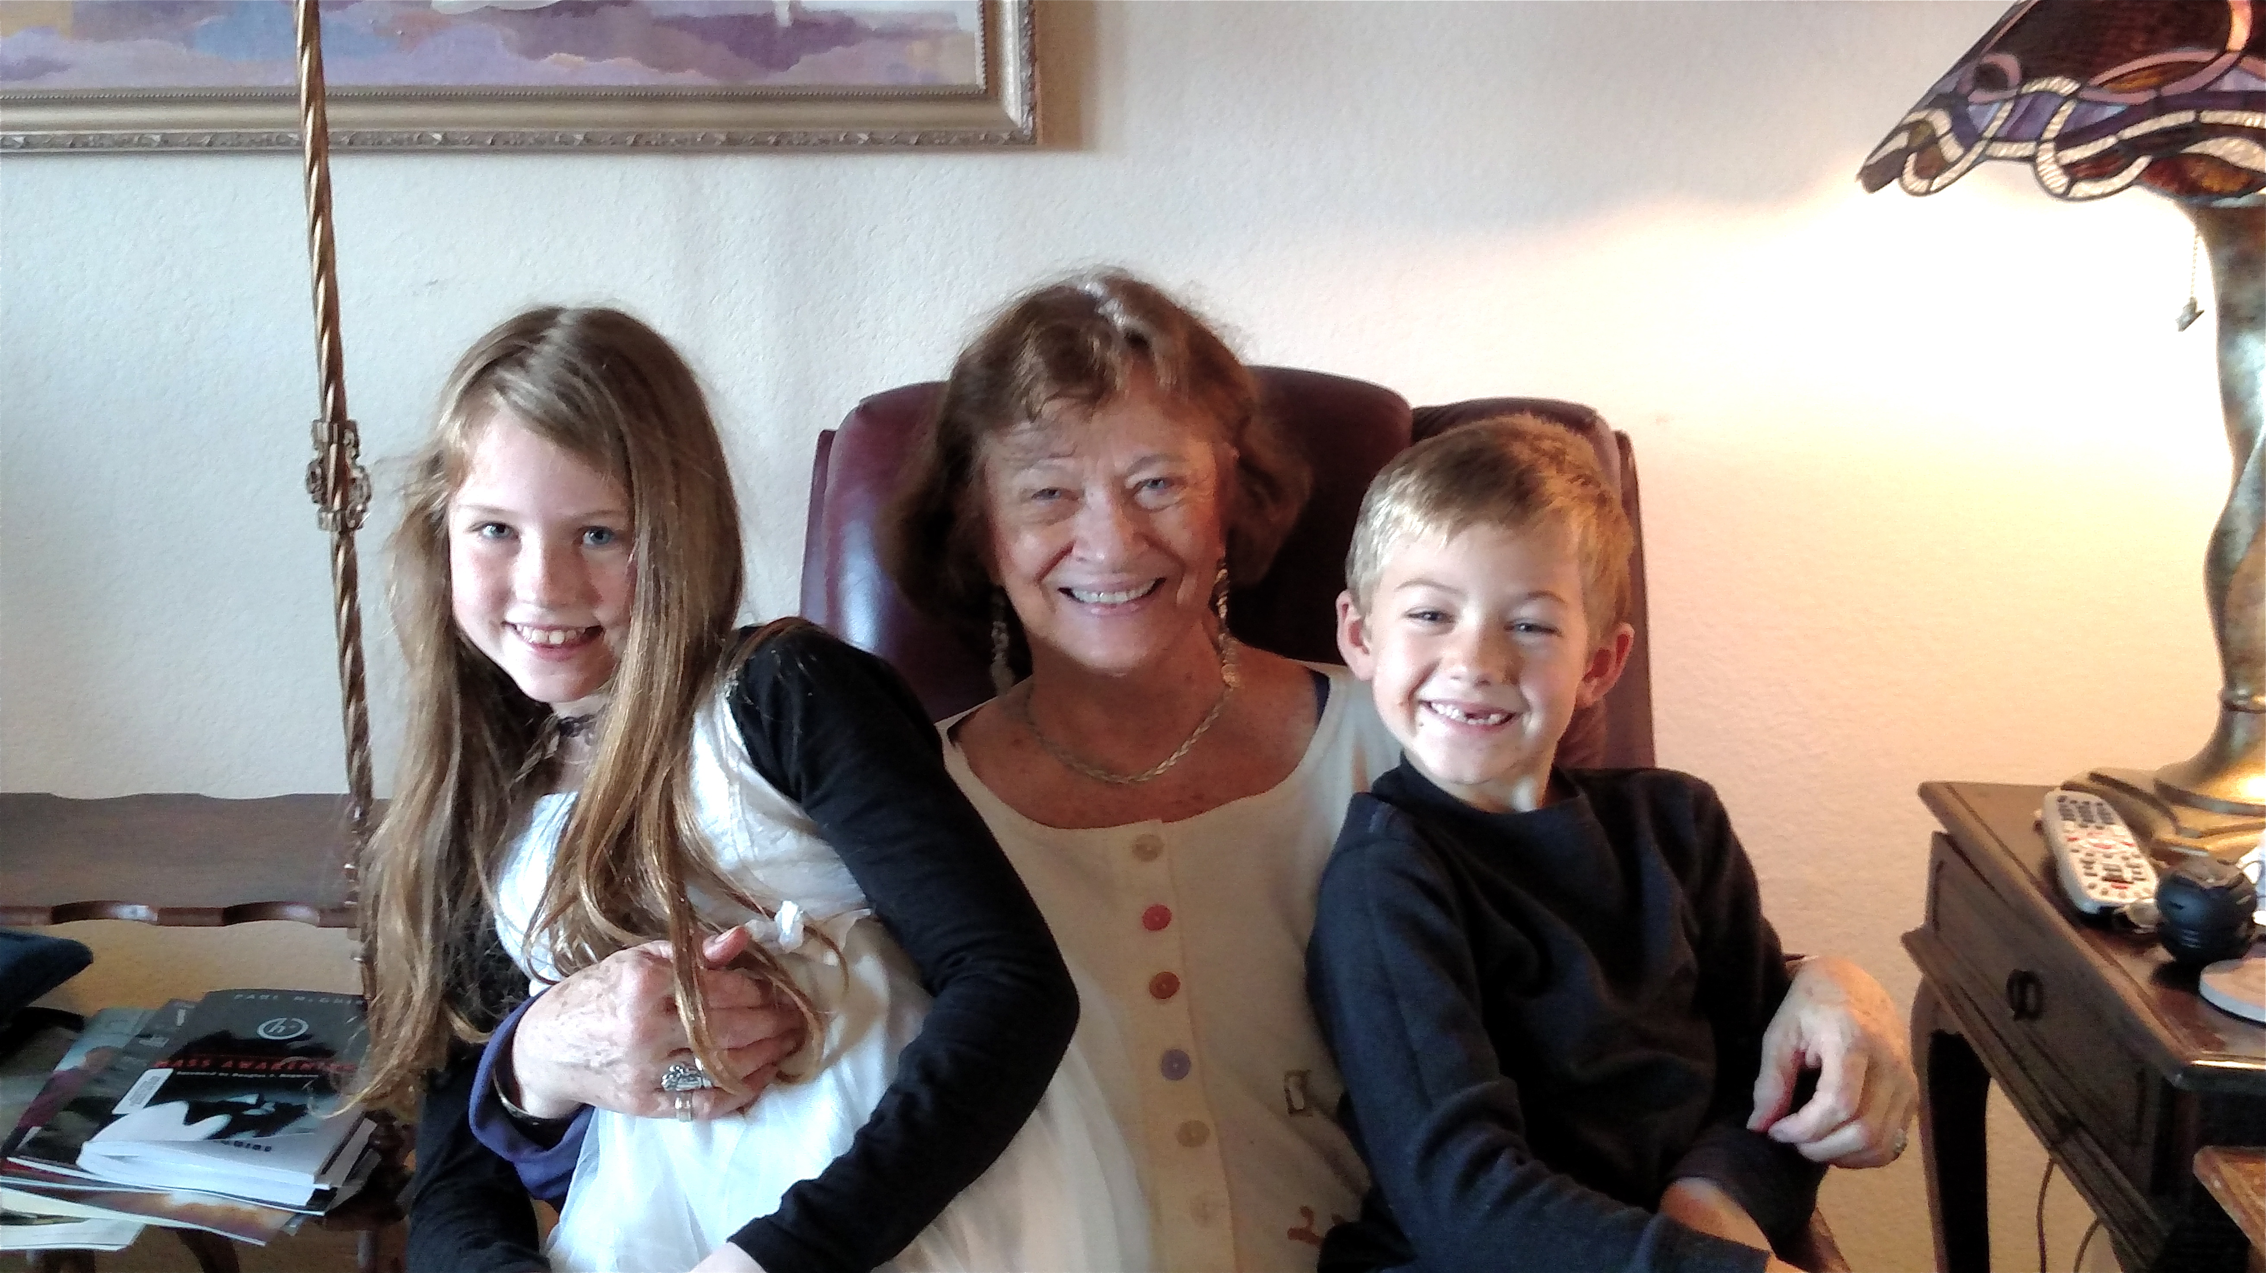
Regarding my bratty cat, Otis that I was chasing when I fell, my older son Grant said “Mom, you need to stop getting your animals from death row; there’s a reason they’re there. It’s like going to the Penitentiary to find a husband. You needed to demand a cat-fax”.

I think I’ve already mentioned this book to you but here is a reminder. I have such talented clients! Jessica Turner from So. Africa has penned a delightful Christian devotional entitled Breathe in the Rhythms of Grace, available on amazon.com Nice holiday suggestion.

This is am FYI: several clients have asked if I’ve ever tried Magnesium Oil for ST but I don’t have ST issues. Then I decided to try some for the Spinal Stenosis and have used it for 3 weeks and so far, no difference but will give it a 2 month trial and let you know. I got the Magnesium 4-Pack from www.healthmasters.com Another product is from QVC..com - Joint Formula Max 88 cream. It’s helpful for pain, though has a medicinal smell. I use it on my low back and legs for the stenosis and have found it’s the only pain cream that really works. Just a reminder that the Occipivot is helpful for the EOP area. I use mine nightly for 20 min. on top of my pillow while I read before going to sleep. Now available on amazon.com. Look for Pivotal Therapy Occipivot. Another FYI – apparently Cocoanut Oil is an Alzheimer’s Remedy. I’ve used it for years for cooking but it has lots of health benefits. Go to Youtube.com and type in Coconut Oil Touted as Alzheimer's Remedy - CBN.com and you’ll find a good video on the subject.

I had a recent email from a client with a helpful tip and here it is:

“For years I have carried a computer bag/briefcase to and from work, probably averaging 10 minutes a day. It bothered my neck to carry it by the handle or add the shoulder strap, so I switched to a backpack. What a difference it made! Obviously the backpack balances the weight on the body but the most significant thing I noticed is that it naturally pulls the shoulders back and forces the torso into a more upright position like we strive to achieve with the military. It made walking much more comfortable. I still have my limits however and walking for long periods of time is still a problem but for everyday routine activities I find the backpack to be the most comfortable way to carry things. Hope this can be a help to others.”

That’s all for this update. I wish all of you a wonderful Christmas and holiday time and an encouraging New Yer. Please stay in touch. Continue to do the best you can to make the program a lifestyle. God bless all of you!

Love,

Abbie

