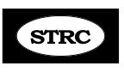

Fall Update 2015
Hi all, time for more this & that. I have mentioned before the importance of posture and how the Military Brace/ Eeeee (MB/Eeee) plays into that. I’ve suggested that you can do that position back against a wall and then try walking away from the wall in the same position and use this as an exercise to teach your body and brain to be erect and straight. Here is a response from one client:
“Hi Abbie,
I want to strongly support the walking from the wall in correct posture. I really think it speeded my recovery and got me over the hump much faster. I did it probably 4 times a day and maybe 10 times for each session. At first I could only walk one or two steps with my head pulling and then up to across the room and then up and down the hallway. Probably took me a month or two, but that is really when the pulling stopped. I should add, when my head pulled and got out of alignment, I returned to the wall to get in the correct position....I did not continue to take steps when out of alignment. I did not want to practice incorrect posture. (That is why I did it up to 10 times because sometimes it would only be a step or two and then back to the wall)”
When I got diagnosed with Macular Degeneration (more on that later), I was told to get a blue shield for my computer screen (available in many sizes. It’s not actually blue but is like polaroid sunglasses for your computer screen, protecting your eyes from harmful rays. It was a 2 second installation – just clear panel with a lip that sits on the top. Look on amazon.com for UV blue light filter for computer screen and you’ll find some.
In the Long Distance Manuel, some of the newer copies, on p. 9 have an error. At the bottom it SHOULD READ: If you cannot do #2, Chin Rotation….” We no longer do that one here in Santa Fe, simply because most ST’rs are too locked up to do it, but if you are able to do it, by all means do so, as it’s good for the muscles and brain. This is just a simple left right left right rotation of the head done slowly either standing or sitting.
Reminder:
NEW EXERCISES!!! (all are on DVD but not in the Manual)
Chin Smile: done following the Head Raise (works muscles in back of skull)
Flex: works muscles in back of head. Theses must be elongated if you want to recover.
Stand with hands clasped behind your bottom. Bend over, head down loose and heavy. Raise your hands/arms high as you can, release and repeat. You must exhale as you raise arms.
Foot Strap: great to elongate muscles from EOP down the back. (get D-ring closure with strap – see Resource Page) www.huggermugger.com In search box, type Foot Strap. Get the 10 foot one with D-ring and adjust as needed.
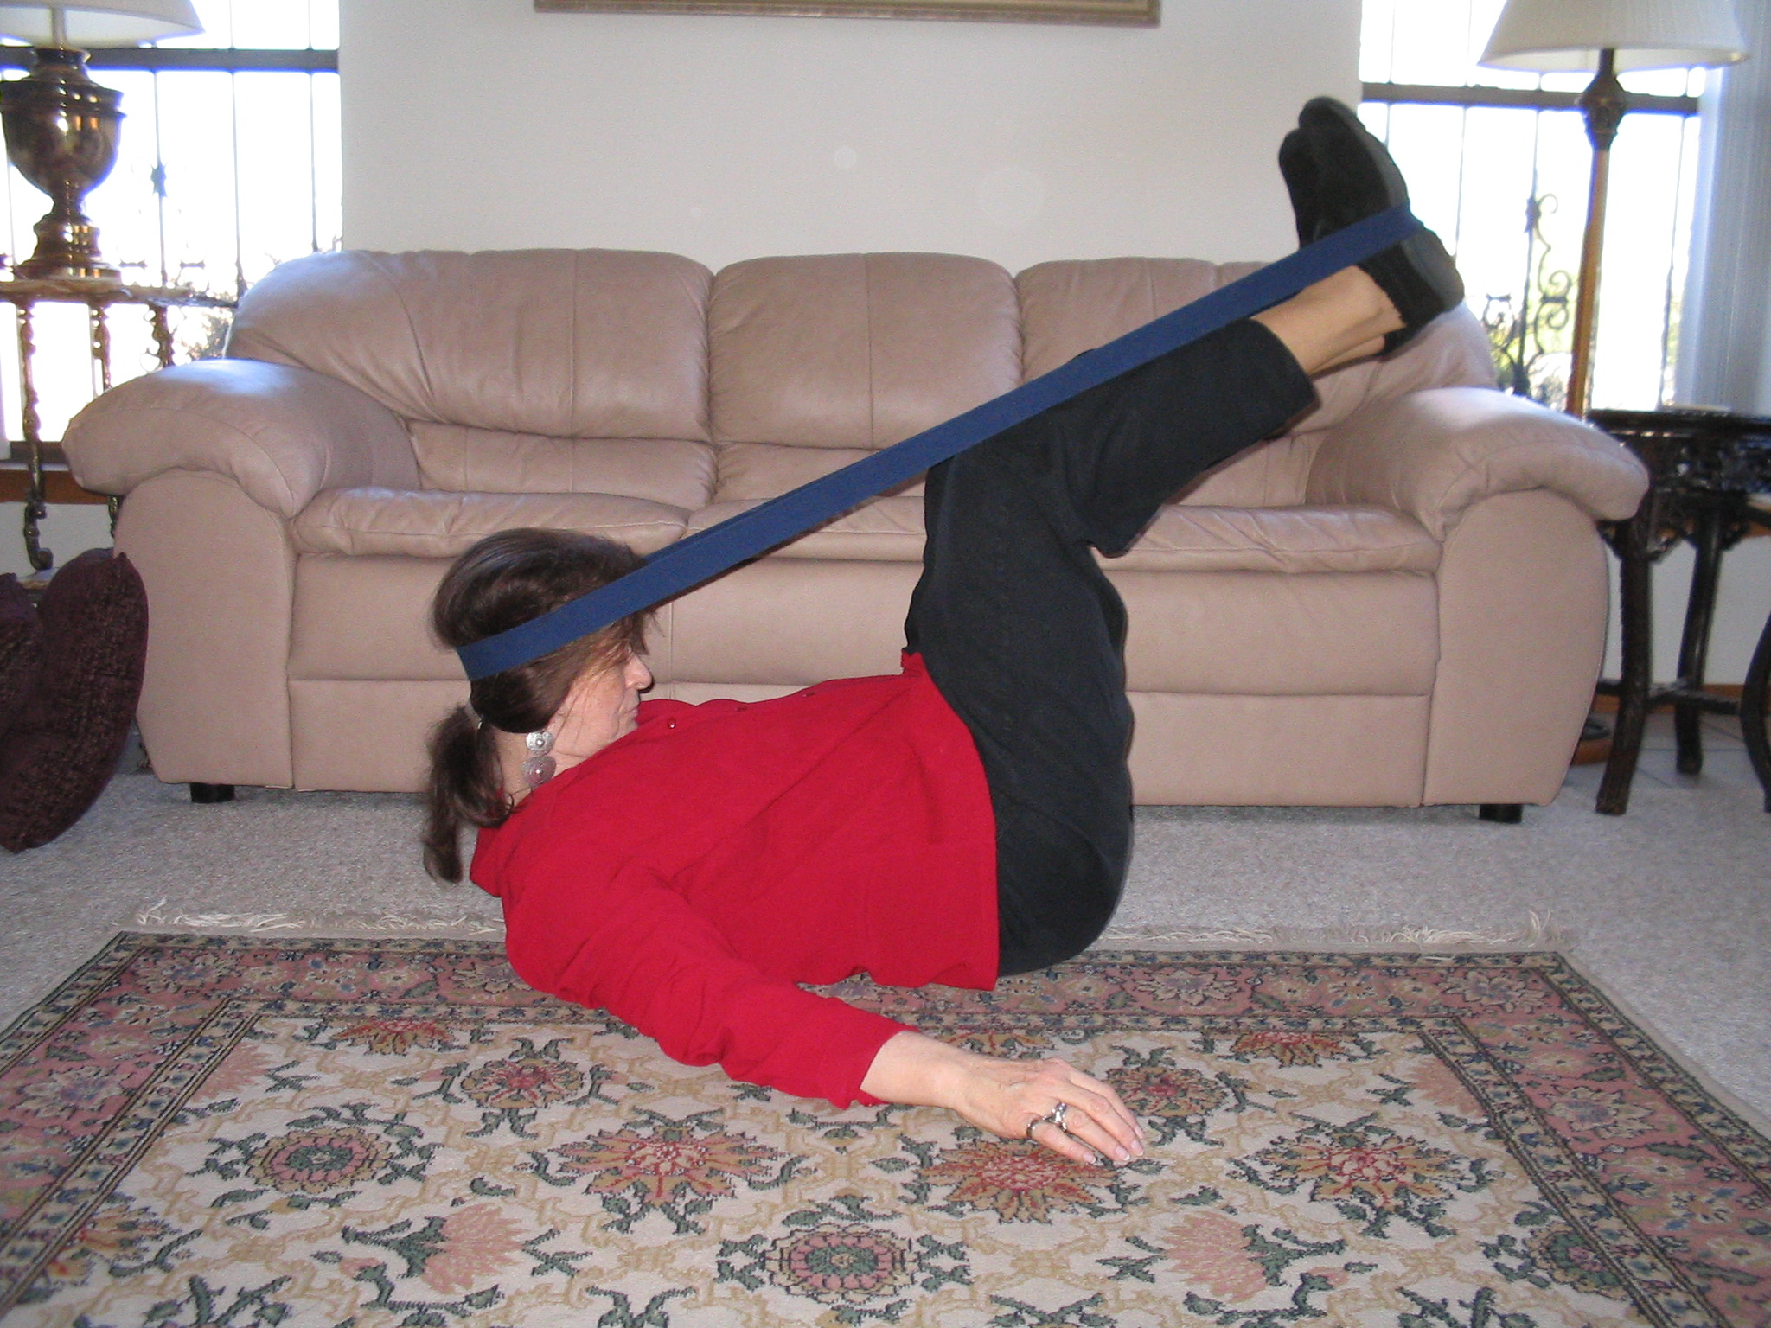
I want to deeply thank all of you who have prayed for me recently! It has been a tough year with a flare up of Plantar Fasciitis, making walking painful at times, chronic dry eye with very expensive meds, severe spinal stenosis with lots of pain, macular degeneration with vision challenges and of late dental surgery with full anesthetic. Just one thing on top of another. I’m wearing foot orthodics and Nikken insoles for the Fasciitis, and it’s better. Am exercising and hanging on the gravity table for the stenosis and sleeping on an adjustable bed – head and feet elevated – and it’s a shade better, The MD was the very worst, as my Mom went blind from that. I went into serious fasting and prayer and felt an assurance from the Lord that He would heal me. One month after the initial diagnosis, it tested dramatically better. The Dr. was stunned. I continue to pray and trust and am also taking the following (for those of you who may have MD or a friend or family member with it) I take daily 8 mg. Astaxanthin, 8 mg. Zeaaxanthin, 24 mg. Lutein, Co-Q 10, and 4 Saffron tabs from New Zealand: http://www.mdrevision.com/purchase-now All of that along with my Shaklee Vitalizer and a healthy diet – no alcohol and very little sugar.
The dental surgery was a major trauma for me due to the fear of pain having 2 back teeth pulled and the problem with no-no meds. I had a fantastic Dr. who spent his own time researching anesthetics for ST and found only one that had no bad reports and that was nitric oxide (laughing gas), so he used that along with 2 and ½ mg. of Versed (he would normally use 6 mg.) which is on the no-no list, but I had to be lout for the surgery, and that tiny amount worked. He looked into Propofol but found one case where it made ST spasms worse so he wouldn’t use it. I’d never heard of the meds he injected into the mouth to deaden that area – but much stronger than Novocain. I also had to use a prescription mouthwash for 3 days prior to surgery; the Dr. said “be very careful not to use too much because it can turn your teeth gray and your tongue black and hairy” – he was SERIOUS – just in time for Halloween - so I hardly used any of it. Anyway, after some extreme anxiety, the procedure went well and I never felt a thing and no pain ever since so am very very grateful for that! Be SURE to give all your doctors a copy of the no-no list, and then do additional research before submitting to any kind of surgery. Given ALL of this, I’m doing remarkably well and looking forward to getting back to work after having had a blessed and restful break.
If you need a copy of the swimming exercises, email me and I’ll send them in two separate emails, as the files are a bit big. I hope you can find a nice warm pool and Jacuzzi as they are helpful and comforting. If you have a therapy pool in your area (ask a local hospital), and you can get a prescription from your doctor for therapy there, perhaps insurance will pay for it.
I know so well how frustrating it can be to be working for months and not seeing a lot of progress – but not giving up is KEY and doing all elements of the program, plodding along one day at a time. Do your best to avoid stress and pamper yourself without guilt! Remember the importance of posture, the MB/Eeee and Drop & Roll throughout the day. Never sleep on that short side! Avoid doing anything that juts the head forward or rolls it back. As winter comes, just a reminder to get an electric mattress pad or electric blanket – so cozy and will help you to stay on your back. I sleep on a Select sleep Number bed on an adjustable frame and continue to play with the number settings but it’s a great bed for lots of different issues. I still favor a waterbed but with Stenosis, it’s not a good choice.
As we look forward to a new year coming, I pray for a blessed and healthy year for all of us. Abbie

