Hi all, again, a bit of this and that:
I may have mentioned this book before but want to remind you of a terrific book,

THE BRAIN THAT CHANGES ITSELF by Norman Doidge available at Amazon.com in paperback and on Kindle.

As I’m now using Mailchimp for bulk emails, you will only see your name in the To: section. For those in the chat groups, please hang onto your list and when you want to send a question/comment to the whole group, you can still certainly do that, and as new people join the list, I’ll let you know. But updates will go to everyone and only your name is visible.
A recent client found the following site and bought the product there and had a near miraculous recovery from carpal tunnel, so if you suffer with that, you might be interested..
http://www.mycarpaltunnel.com/
For those of you here recently, a personal note, I’ve been increasingly aware that my beautiful Labradoodle PandaBear was not to be my dog; he was so bored and frustrated here, and I couldn’t give him all he needed and so found him a wonderful new home with a big family. He gets daily hikes, lots of play time with the kids, doggie day care to socialize with other dogs and so now has a forever home where he is entertained, exercised and well cared for. I miss him but know it was the right move.
The terrific old SOS (Sub Occipital Soother) cranial sacral device is no longer available. The next best thing I’ve found is this:

Details about BODY BACK COMPANY BLUE STILL POINT RELAX MASSAGE PAD NECK SUPPORT PAIN RELIEF
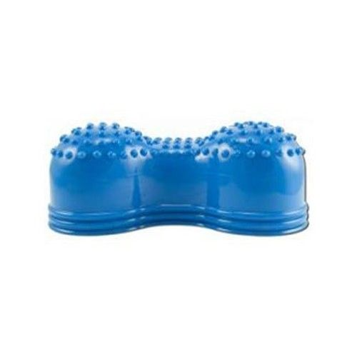on ebay.com:
http://www.ebay.com/itm/BODY-BACK-COMPANY-BLUE-STILL-POINT-RELAX-MASSAGE-PAD-NECK-SUPPORT-PAIN-RELIEF-
or Amazon.com: it’s called Neck pain Reliever
http://www.amazon.com/Evergym-Dachin-Enterprises-Co-Reliever/dp/B00DUYFD3M/ref=pd_rhf_se_p_tnr_1

new promo code for Clark: STRC for waived postage

Place it right at the EOP when lying down – for about 20 minutes max. It just gives you a little neck massage/release: subtle but feels good. I use mine.
You’ll see, if you visit our site, that our program here in Santa Fe has been revised. We now offer only one In-House Program at $1,600.00 plus of course the Long Distance Program still at $500.00. The Board and I felt that all clients will benefit from the professional massage one day during their week and from the Therapy Pool, so have combined the Original and Premier programs into one. I’ve found a great new Massage Therapist. It hasn’t been easy since Myra left and Kat move to North Carolina, but found Terri on Craig’s List of all places. She has been training with Myra’s book and DVD, has a heart for ST’rs and gives a great massage.
Just a reminder that I need a new Director!! I’m booked into October, hit 76 in October and am anxious to get someone trained to do the In-House Program. I have a sense someone or a couple has indeed been called but for some reason has not responded. Please continue to pray. This is such a unique and wonderful opportunity.
Please remember the Eeee is always combined with the military. Do some stretching throughout the day each day to “keep the wheels oiled” and continue to let your body know that YOU are the boss. Remember too that an electric heated mattress pad will help you stay on your back at night. After 40 years I have given up the waterbed and got an adjustable bed, which seems to be helping with the Sciatica along with hanging daily on the gravity table and stretching.
I’ll be out of town from July 25th-28th, but will try to respond to emails using my ipad. A house sitter will be here but won’t be answering the phone. Blessings to all of you as always. Abbie

