Hi everyone, happy Spring!
Again, lots of this ‘n that in this update. An area that interests me a lot is Benzo withdrawal. I had such a nightmare with withdrawal from Ativan over 20 years ago and the Benzos are what doctors almost always recommend for ST. It’s a mixed bag, because they can certainly help with pain and spasm but are so addictive and withdrawal is terrible for those who have taken them regularly over a period of time. The more you take, the more problematic. I have clients who only take a Klonopin or some other Benzo rarely when needed and that’s probably not a problem, but best to be informed. Here is some free info on Benzo withdrawal online. This is also available as a DVD - at amazon.com But this youtube is free and well worth watching.
Benzo Withdrawal Welcome to Hell by Brian Baxter (a DVD) but you can see it free here
http://www.youtube.com/watch?v=97Wlx_UzWYg

http://ashtonbenzomanual.com/ashton_chapter_1.pdf
also this is a good page (he mentions taking Benedryl - but don’t as it’s on the no-no list for ST’rs.
http://easycalm.com/blog/category/ativan-withdrawal/

The only sweets I recommend are Xylitol, honey or maple syrup. Stevia is also fine if you like it. Here is some info on the
dangers of splenda:
http://articles.mercola.com/sites/articles/archive/2011/04/26/major-media-finally-exposes-splendas-lies.aspx

Here is a pro-life alternative to the Affordable Care Act (Obamacare) for those who might be interested:
These 3 groups are actually Christian ministries. I was with Samaritan Ministries for many years before I got on Medicare and loved it. My premium at that time was &70.00 a month for full coverage! These operate as insurance companies but do not call themselves that, but rather are non-profits. They are health care sharing plans. Anyway, you might want to look into them:

Medi-Share http://mychristiancare.org/ see link there for Medi-Share

Samaritan Ministries International http://samaritanministries.org/

Christian Healthcare Ministries.
http://www.chministries.org/

Re. pain, here is an email from a client that might interest you. I can’t recommend this as I’m not in pain and have never tried it, but FYI here it is.
“Wanted to share info about Acti-Patch, it really works for me to alleviate pain. It is only a wire hooked to a watch battery so rather pricey for what it is-but it works. I tape it to my shoulder/neck area over night and in the morning the muscles are completely relaxed. I first saw it on Dr. Oz over a year ago and ordered it through Amazon, was doubtful but it had hundreds of good reviews so tried it. It really works only thing is it is made in Canada and can no longer ship to USA. I have a friend in Canada and ordered the one with adhesives sent to her address and she shipped to me, but at a cost of $24 for shipping. I thought you would like to know about it anyway, the website is http://www.actipatch.ca/ wondered if you know of anything similar in the USA. I haven't found anything on the web like it.”
(this seems to be available from amazon.com)

I mentioned in the last update my interest in this whole subject of the 5th Trigeminal nerve (www.thefifthnerve.com) and it’s relationship to the basil ganglia, the misfiring of the nerve there that I have a hunch is causing the over-production of both Acetylcholine and Adrenalin and the spasms with ST, as that fifth nerve gets pinched because some bones in the jaw area and too close and so don’t permit room for the 5th nerve to travel thru unencumbered. Not sure I’m accurate about all of this, but it seems to be close to what is happening. When we do the military with the Eeeee (which should always be used with the military) those bones in the jaw apparently spread a bit and thus allow normal function of the 5th nerve, and this is what is allowing clients to come into recovery mode – at least that’s what I think is happening. Here is a jpg of the Trigeminal nerve.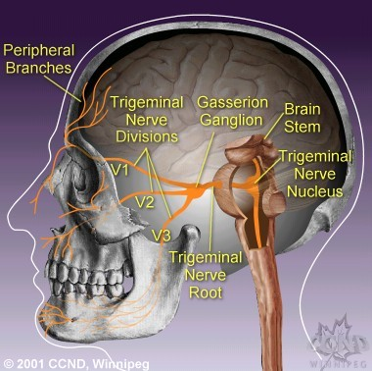

Within the last year or so, I lost my source for the headharness from Weightlifter’s Warehouse, and so began using one from Kamway, but recently have had some problems with that company and now no longer recommend getting the harness from them. The Kamway was running around $50.00. I found a terrific harness at Amazon.com. I ordered it and it arrived today – it’s perfect and uses a Velcro closure so will fit everyone. The price is best I’ve ever found on a harness. Here it is:
Harbinger Leather Head Harness #373301 @ Amazon.com
http://www.amazon.com/gp/product/B001LX1AOU/ref=oh_details_o00_s00_i00?ie=UTF8&psc=1
$29.90 with FREE shipping in the U.S.
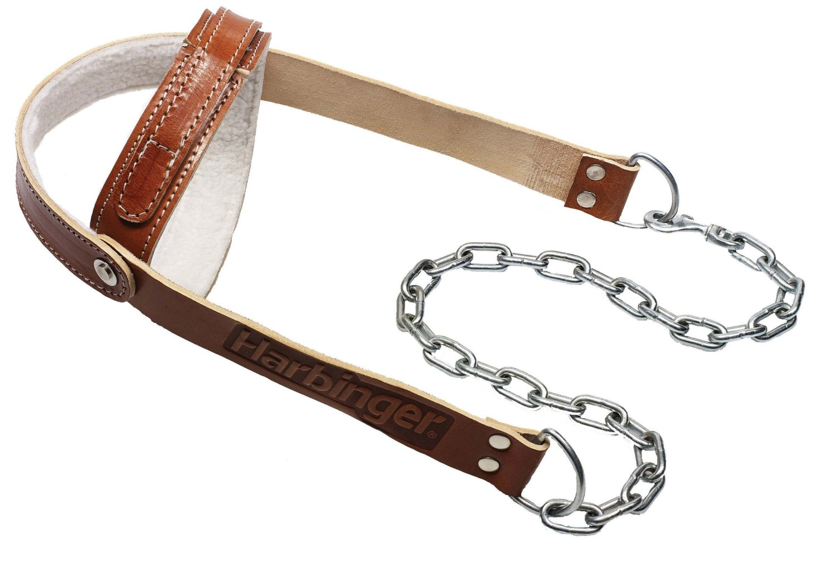
For those of you without a computer, you can get it from Colonial medical for $24.95 but will probably have to add postage. Their phone is: 800-323-6794.

Keep on keeping on, being consistent and patient as you tutor your body into that new land of normal – one day at a time.
Blessings to all of you, Abbie

